Electrical System Form FSAE-2015

Portland State University

Car #E221



Team Contact: Quinn Sullivan [qsullivan11@gmail.com](mailto:qsullivan11@gmail.com)

Table of Contents

Table of Contents 2

I List of Figures 6

II List of Tables 10

III. List of Abbreviations 11

1 System Overview 12

2 Electrical Systems 14

2.1 Shutdown Circuit 14

2.1.1 Description/concept 14

2.1.2 Wiring / additional circuitry 15

2.1.3 Position in car 17

2.2 IMD 17

2.2.1 Description (type, operation parameters) 17

2.2.2 Wiring/cables/connectors/ 19

2.2.3 Position in car 20

2.3 Inertia Switch 21

2.3.1 Description (type, operation parameters) 21

2.3.2 Wiring/cables/connectors/ 21

2.3.3 Position in car 21

2.4 Brake Plausibility Device 22

2.4.1 Description/additional circuitry 22

2.4.2 Wiring 23

2.4.3 Position in car/mechanical fastening/mechanical connection 23

2.5 Reset / Latching for IMD and BMS 25

2.5.1 Description/circuitry 25

2.5.2 Wiring/cables/connectors 25

2.5.3 Position in car 25

2.6 Shutdown System Interlocks 25

2.6.1 Description/circuitry 25

2.6.2 Wiring/cables/connectors 26

2.6.3 Position in car 26

2.7 Tractive system active light 26

2.7.1 Description/circuitry 26

2.7.2 Wiring/cables/connectors 28

2.7.3 Position in car 29

2.8 Measurement points 30

2.8.1 Description 30

2.8.2 Wiring, connectors, cables 30

2.8.3 Position in car 30

2.9 Pre-Charge circuitry 31

2.9.1 Description 31

2.9.2 Wiring, cables, current calculations, connectors 33

2.9.3 Position in car 34

2.10 Discharge circuitry 34

2.10.1 Description 34

2.10.2 Wiring, cables, current calculations, connectors 34

2.10.3 Position in car 36

2.11 HV Disconnect (HVD) 36

2.11.1 Description 36

2.11.2 Wiring, cables, current calculations, connectors 36

2.11.3 Position in car 37

2.12 Ready-To-Drive-Sound (RTDS) 38

2.12.1 Description 38

2.12.2 Wiring, cables, current calculations, connectors 38

2.12.3 Position in car 39

3 Accumulator 40

3.1 Accumulator pack 1 40

3.1.1 Overview/description/parameters 40

3.1.2 Cell description 40

3.1.3 Cell configuration 41

3.1.4 Cell temperature monitoring 42

3.1.5 Battery management system 44

3.1.6 Accumulator indicator 47

3.1.7 Wiring, cables, current calculations, connectors 47

3.1.8 Accumulator insulation relays 48

3.1.9 Fusing 49

3.1.10 Charging 50

3.1.11 Mechanical Configuration/materials 51

4 Energy meter mounting 54

4.1 Description 54

4.2 Wiring, cables, current calculations, connectors 54

4.3 Position in car 54

5 Motor controller 55

5.1 Motor controller 1 55

5.1.1 Description, type, operation parameters 55

5.1.2 Wiring, cables, current calculations, connectors 55

5.1.3 Position in car 56

6 Motors 58

6.1 Motor 1 58

6.1.1 Description, type, operating parameters 58

6.1.2 Wiring, cables, current calculations, connectors 59

6.1.3 Position in car 60

7 Torque encoder 62

7.1 Description/additional circuitry 62

7.2 Torque Encoder Plausibility Check 63

7.3 Wiring 64

7.4 Position in car/mechanical fastening/mechanical connection 65

8 Additional LV-parts interfering with the tractive system 66

8.1 Vehicle Control Unit 66

8.1.1 Description 66

8.1.2 Wiring, cables, 66

8.1.3 Position in car 68

8.2 DC/DC converter 69

8.2.1 Description 69

8.2.2 Wiring, cables, 69

8.2.3 Position in car 70

8.3 Low Voltage Power Source 70

8.3.1 Description 70

8.3.2 Wiring, Cables 70

8.3.3 Position in car 71

9 Overall Grounding Concept 72

9.1 Description of the Grounding Concept 72

9.2 Grounding Measurements 72

10 Firewall(s) 73

10.1 Firewall 1 73

10.1.1 Description/materials 73

10.1.2 Position in car 73

11. Appendix 74

# List of Figures

Figure 1‑1: Block diagram of the tractive system 12

Figure 1‑2: Block diagram of the controls/GLV system 12

Figure 2‑1: Schematics of shutdown circuit 16

Figure 2‑2: Shutdown Circuit location 17

Figure 2‑3 IMD circuit schematics. The last portion of the circuit (relay K1) directly controls the shutdown circuit from Figure 2‑1 20

Figure 2‑4 IMD position 20

Figure 2‑5: Inertia switch location drawing 21

Figure 2‑6 BSPD PCB layout 23

Figure 2‑7 BSPD schematics 24

Figure 2‑8 Placement of the brake pedal and the master cylinder 24

Figure 2‑9 Brake switch and its location 25

Figure 2‑10 Inerlocks wiring diagram. Removable part of the interlock is dashed 26

Figure 2‑11 TSAL & RTDS enclosure drawing 27

Figure 2‑12 Wiring diagram of TSAL 28

Figure 2‑13 Board Layout of TSAL (board dimensions are in inches) 29

Figure 2‑14 Position of TSAL in the car, under the top of the main roll hoop 29

Figure 2‑15 TSMP schematics 30

Figure 2‑16 Location of TSMP in the car 31

Figure 2‑17 Close of view of TSMPs with caps on and off 31

Figure 2‑18 Precharge Plot of Percentage Maximum Voltage vs. Time 32

Figure 2‑19 Precharge Plot of Current vs. time 32

Figure 2‑20 Dicharge circuit voltage vs time 35

Figure 2‑21 Dicharge circuit current vs time 35

Figure 2‑22 HVD wiring, LV wires ommited for clarity. Blue is HV+, Green is HV-, HVD located in top accumulator container 37

Figure 2‑23 HVD location on the left side of the top battery box 37

Figure 2‑24 Wiring diagram of RTDS (VCU’s digital output is „sinking current“, see Section 8.1 for details) 38

Figure 3‑1 Cells assmbled into cell pack of two (2 parallel) 42

Figure 3‑2 Battery module placement within the accumulator container 42

Figure 3‑3 Cell thermistor characteristics 43

Figure 3‑4 Location of thermistors on the cell packs 43

Figure 3‑5 Flexi circuit connecting cells and thermistors with the battery management board 44

Figure 3‑6 BMS system overview 45

Figure 3‑7 Wiring diagram of AMS 46

Figure 3‑8 RLEC board functions 47

Figure 3‑9 Accumulator light schematics 47

Figure 3‑10 Charger schematics 51

Figure 3‑11 Cells tie rod connection 52

Figure 3‑12 Adding cell tabs on the assembled batetry module 52

Figure 3‑13 Adding connector and plastic shields to the battery module 53

Figure 5‑1 Position of the motor controller (rear and isometric view) 56

Figure 5‑2 Position of the motor controller (side view) 57

Figure 6‑1 Plot of power vs. RPM and Torque vs. RPM for Remy HVH250 motor 59

Figure 6‑2 Motor traction connection 60

Figure 6‑3 Motor and enclosure placement (rear view) 61

Figure 6‑4 Motor and enclosure placement (side view) 61

Figure 7‑1 Torque encoder functional description 63

Figure 7‑2 Motor Controller troque input mapping 64

Figure 7‑3 Torque encoder wiring schematics (simplified) 65

Figure 7‑4 Location of the pedal assembly 65

Figure 8‑1 VCU pinout 67

Figure 8‑2 VCU Digital input schematics, DIN2 is from the AMPSEAL connector, D50 goes directly into Arduino chip 67

Figure 8‑3 VCU Digital output, DOUT0 and DOUT1 are on AMPSEAL connector, D4 and D5 are outputs from Arduino chip 68

Figure 8‑4 VCU Analog input circuit, AIN1 is from AMPSEAL connector, A2 is analog input directly fed to Arduino chip 68

Figure 8‑5 VCU position (side view) 69

Figure 8‑6 DC/DC Converter connection diagram, HV lines are highlighted blue. DCDC_ENABLE goes directly to VCU digital output, 12V_OUT goes directly to LV battery. 70

Figure 8‑7 LV power source wiring diagram, note 12AWG wire coming from battery to PDM60, and 18AWG wire used for rest of the LV subsystems. 71

Figure 8‑8 Location of LV battery and PDM60 in the car (side view) 71

Figure 10‑1 Position of rear firewall 73

Figure 11‑1 (Section 2.6) TSMP Amphenol 6-pin DIN connector and receptacle, full datasheet available at http://www.mouser.com/ds/2/18/28_ecomate_052009_e-86580.pdf 74

Figure 11‑2 (Section 2.8) Shrouded banana jack for TSMPs 75

Figure 11‑3 (Section 2.8) Resistor for TSMPs 75

Figure 11‑4 (Section 2.11) HV disconnect, Complete data sheet located at: http://www.te.com/content/dam/te/global/english/industries/hybrid-electric-mobility-solutions/amp-msd-tech-sheet.pdf 76

Figure 11‑5 (Section 2.6) HV accumulator connector receptacle, Complete data sheet located at: http://www.mouser.com/ds/2/276/1714669001_PCB_HEADERS-295262.pdf 77

Figure 11‑6 (Section 2.6) HV accumulator connector header, full datasheet at http://www.mouser.com/ds/2/276/1714671001_PCB_HEADERS-294724.pdf 78

Figure 11‑7 (Section 2.1) S505H series fuse Complete datasheet at http://www.mouser.com/ds/2/87/BUS_Elx_DS_4406_S505H_Series-335925.pdf 79

Figure 11‑8 (Section 2.7) Acrylic Conformal Coating 419C, full datasheet located at http://www.mgchemicals.com/products/protective-coatings/conformal/acrylic-conformal-coating-419c/ 79

Figure 11‑9 (Section 8.2) DC/DC converter specs, complete datasheet located at http://www.onlinecomponents.com/datasheet/sp200135.aspx?p=11953391 79

Figure 11‑10 (Section **Error! Reference source not found.**) PDM60 specs, complete datasheet located at http://pdm60.com/wp-content/uploads/2014/08/PDM60-General-Installation-and-Operation-Manual-052213-1.pdf 79

# List of Tables

Table 1‑1 General parameters 13

Table 2‑1 List of switches in the shutdown circuit 14

Table 2‑2 Wiring – Shutdown circuit 17

Table 2‑3 Parameters of the IMD 19

Table 2‑4 Parameters of the Inertia Switch 21

Table 2‑5 Brake switch data 23

Table 2‑6 Parameters of the TSAL 27

Table 2‑7 General data of the pre-charge resistor 33

Table 2‑8 General data of the pre-charge relay 33

Table 2‑9 Basic fuse data 34

Table 2‑10 General data of the discharge circuit 36

Table 3‑1 Main accumulator parameters 40

Table 3‑2 Main cell specification 41

Table 3‑3 Cell cutoff values 45

Table 3‑4 Wire data for BMS connections 48

Table 3‑5 Cable data for battery tractive system connections² 48

Table 3‑6 Basic AIR data 49

Table 3‑7 Basic fuse data 49

Table 3‑8 General charger data 51

Table 5‑1 General motor controller data 55

Table 5‑2 Wire data of Irradicated Exrad Shielded 2 AWG battery cable 56

Table 6‑1 General motor data 59

Table 7‑1 Torque encoder data 62

# List of Abbreviations

**A:** Amps

**AIR:** Accumulator Isolation Relays

**AMS:** Accumulator Management System

**ATF:** Automatic Transmission Fluid

**AWG:** American Wire Gauge

**BMS:** Battery Management System

**CAN:** Controller Area Network

**DC:** Direct Current

**DCP:** Direct Current Pulse

**GLVS:** Grounded Low Voltage System

**HT:** High Torque

**HV:** High Voltage

**HVD:** High Voltage Disconnect

**IMD:** Insulation Monitoring Device

**RTDS:** Ready-To-Drive-Sound

**SST:** Speed Start Measurement

**TEPD:** Throttle Encoder Plausibility Device

**TSAL:** Tractive System Active Light

**TSMP:** Tractive System Measuring Points

**TSMS:** Tractive System Master Switch

**VCU:** Vehicle Control Unit

**VDC:** Voltage Direct Current

# System Overview

The electrical system is divided into two sub-systems. The low voltage system is 12V DC, the high voltage is 196 V max. The goal of the system is to keep things simple, reliable, and safe. The selection of using proven hardware and components was used instead of recreating components whenever possible. High-level diagram of the tractive system is shown in Figure 1‑1, block diagram of individual subsystems is shown in Figure 1‑2. Basic information about the car can be found in Table 1‑1.

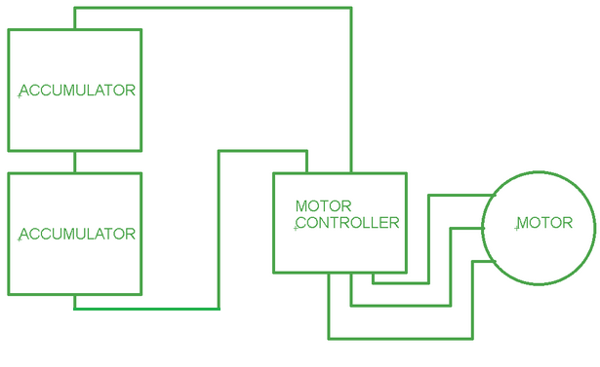

Figure 1‑1: Block diagram of the tractive system

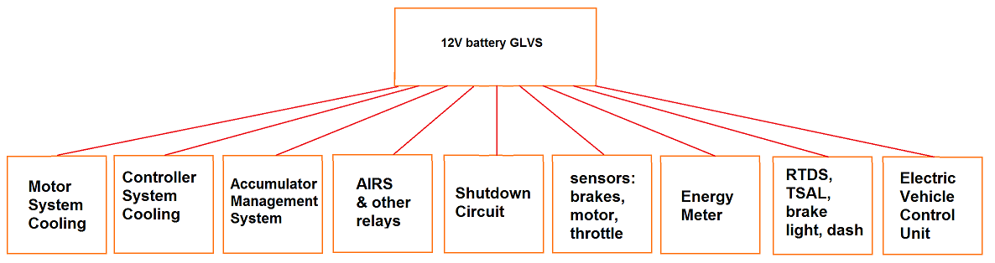

Figure 1‑2: Block diagram of the controls/GLV system

|  |  |
| --- | --- |
| Maximum Tractive-system voltage: | 196 VDC |
| Nominal Tractive-system voltage: | 180 VDC |
| Control-system voltage: | 12 VDC |
| Accumulator configuration: | 48s2p |
| Max voltage per container | 98 VDC |
| Total Accumulator capacity: | 35Ah |
| Motor type: | Permanent magnet AC motor |
| Number of motors: | 1 |
| Maximum combined motor power in kW | 50 kW (68 hp) |

Table 1‑1 General parameters

# Electrical Systems

## Shutdown Circuit

### Description/concept

The shutdown circuit contains the safety circuits listed in Table 2‑1. Everything is in series, except the AIR’s are in parallel with each other. If circuit is opened by the AMS or IMD, the tractive system is disabled until being manually reset by a person directly at the car which is not the driver. The driver cannot reactivate the tractive system, they can’t physically reach the reset buttons in the rear of the car. No remote reset is installed.

Note that we use a standard motorcycle battery, connected via 12AWG wire to 40A fuse, and then to GLV_MASTER_SWITCH. From there we connect to Power Distribution Module (PDM60, described in details in Section 8.3). PDM60 acts as a programmable current limited switching power supply, in this case supplying 12V and max 10A to the shutdown circuit. The rest of the shutdown curcuit uses 18AWG.

The two master switches will electrically turn off the 12V supply, and open the AIR’s when switched “off”. For the brake over travel switch, there is a rod attached to a toggle switch, which pulls open a contact on a relay. The tractive system does apply regenerative braking, and current flows to the high voltage battery pack. If the shutdown circuit is disconnected, both tractive system current and regenerative current is disconnected. The motor controller “bleeds” off excess energy.

|  |  |
| --- | --- |
| Part | Function |
| Main Switches ( GLVMS, TSMS) | Normally open |
| Brake over travel switch (BOTS) | Normally closed |
| Shutdown buttons (SDB) | Normally closed |
| Insulation Monitoring Device (IMD) | Normally open |
| Accumulator Management System (BMS) | Normally open |
| Inertia Switch | Normally closed |
| Interlocks - charger, AMS, IMD, BSPD, accumulators | Closed when circuits are connected |
| Brake System Plausibility Device | Normally Closed |

Table 2‑1 List of switches in the shutdown circuit

### Wiring / additional circuitry

The shutdown circuit wiring is 18 AWG, stranded insulated copper wire with all components in series. All connections are made using IP 65 rated Deutsch connectors. The schematic of shutdown circuit is shown in Figure 2‑1. Table 2‑2 summarizes basic info about the shutdown circuit.

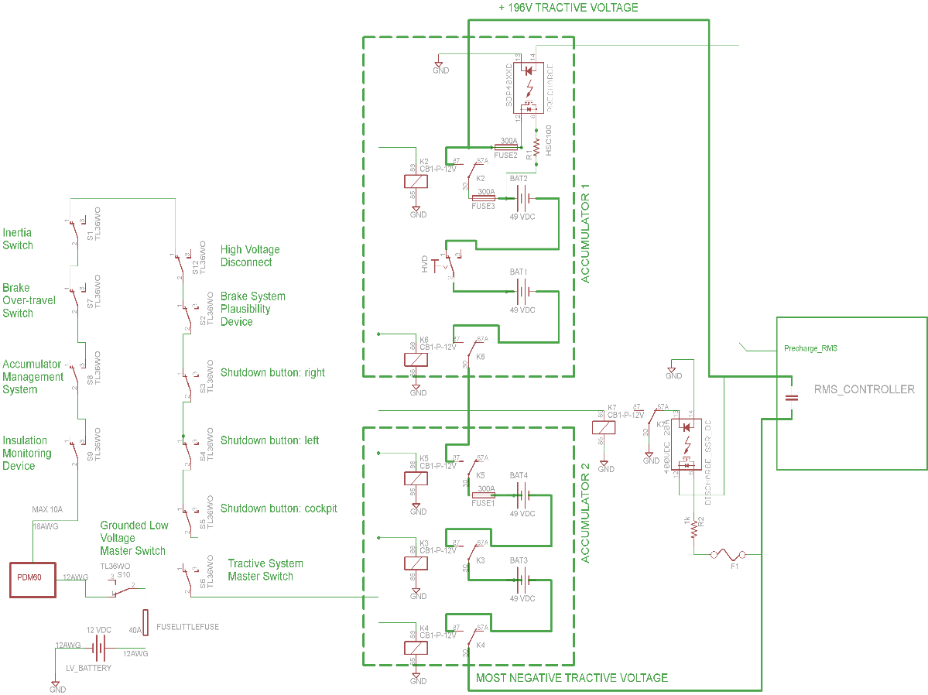

Figure 2‑1: Schematics of shutdown circuit

|  |  |
| --- | --- |
| Total Number of AIRs: | 6 |
| Current per AIR: | 0.13A |
| Additional parts consumption within the shutdown circuit: | 3A |
| Total current: | 3.78A |
| Cross sectional area of the wiring used: | 0.823 mm² (18 AWG) |

Table 2‑2 Wiring – Shutdown circuit

### Position in car

The shutdown circuit is distributed throughout the car, as shown in Figure 2‑2.

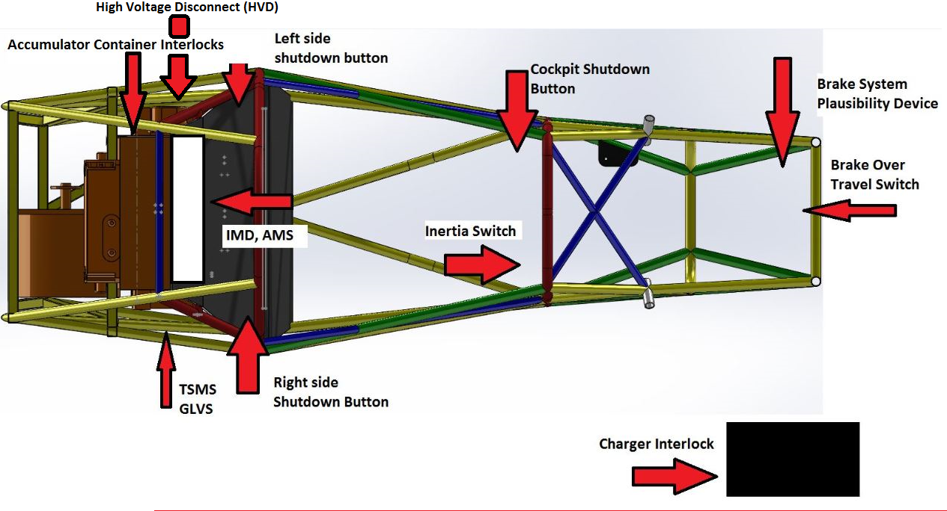

Figure 2‑2: Shutdown Circuit location

## IMD

### Description (type, operation parameters)

An insulation monitoring device (IMD) is installed in the tractive system that continuously monitors the electrical insulation resistance between the active HV conductors of the drive system and the chassis ground reference earth. The IMD is a Bender A-ISOMETER ® iso-F1 IR155-3204. The response value of the IMD is set to 500 Ohm / Volt, related to the maximum tractive system operation voltage. The tractive system maximum voltage is 196V, so the IMD is at 98 k-ohms. The IMD specs are shown in Table 2‑3.

Once power is switched on the IMD performs a Speed Start measurement (SST). This provides the first estimated insulation resistance during a maximum time of 2 seconds. The Direct Current Pulse (DCP) system starts immediately after to continuously take measurements. Faults in the connecting wires or any functional faults will be recognized, and drive a relay open.

Since the IMD provides a LOW signal when there is a fault, the signal is run through an inverter ( [74LS04](http://www.skot9000.com/ttl/datasheets/4.pdf)) to provide a HIGH signal in the event of a fault. The signal is fed then to the gate of a thyristor([littelfuse S4S8EX datasheet](http://www.littelfuse.com/~/media/electronics/datasheets/switching_thyristors/littelfuse_thyristor_sxx8xsx_datasheet.pdf.pdf)) which will activate the shutdown circuit. The thyristor will keep conducting as long as the device is forward biased even after the gate signal is removed, thus keeping the shutdown circuit activated and the tractive system disabled until it can be reset by a switch that will not accessible to the driver.

The status of the IMD is shown to the driver by an indicator light in the cockpit that is easily visible even in bright sunlight. In the case of a fault, too low insulation resistance, IMD error, ground error, undervoltage detected or IMD loss of power, the relay will open, and a normally closed contact will close,an indicator light will turn on. It is wired in series with a 470 ohm resistor to decrease the current to ~19 mA. The IMD indicator light is clearly marked with the lettering “IMD”.

In case of an insulation failure or an IMD failure, the IMD will open the shutdown circuit without the influence of any programmable logic. If the shutdown circuit is opened by the IMD the tractive system will remain disabled until being manually reset by a person directly at the car which is not the driver. It is not possible for the driver to re-activate the tractive system from within the car in case of an IMD fault because the reset button is at the rear of the car out of the driver’s reach. No remote reset is installed.

Applying an IMD test resistor, with a value less than 98 k-ohms, between HV+ and GLV system ground deactivates the system. Disconnecting the test resistor does not reactivate the system. The tractive system remains inactive until it is manually reset.

|  |  |
| --- | --- |
| Supply voltage range: | 10..36VDC |
| Supply voltage | 14VDC |
| Environmental temperature range: | -40..105°C |
| Selftest interval: | Startup, then 15 minute intervals |
| High voltage range: | DC 0..1000V |
| Set response value: | 98 k-ohms (500 ohms/volt) |
| Max. operation current: | 2mA |
| Approximate time to shut down at 50% of the response value: | 20s |

Table 2‑3 Parameters of the IMD

### Wiring/cables/connectors/

The connections on the vehicle side use metal ring terminals. The connections on the IMD side use a harness secured to the board. The XLA wires are Thermax M22759/16-18-3 orange 18 AWG cable. None of the GLVS wiring and components are orange in color. The high voltage wires are fused with 6.3A [Bussmann BK-S505H-V-6.3-R](http://www.mouser.com/ds/2/87/BUS_Elx_DS_4406_S505H_Series-335925.pdf) fuses rated at 400 VDC, with datasheet shown in Figure 11‑7. The IMD circuit schematics is shown in Figure 2‑3.

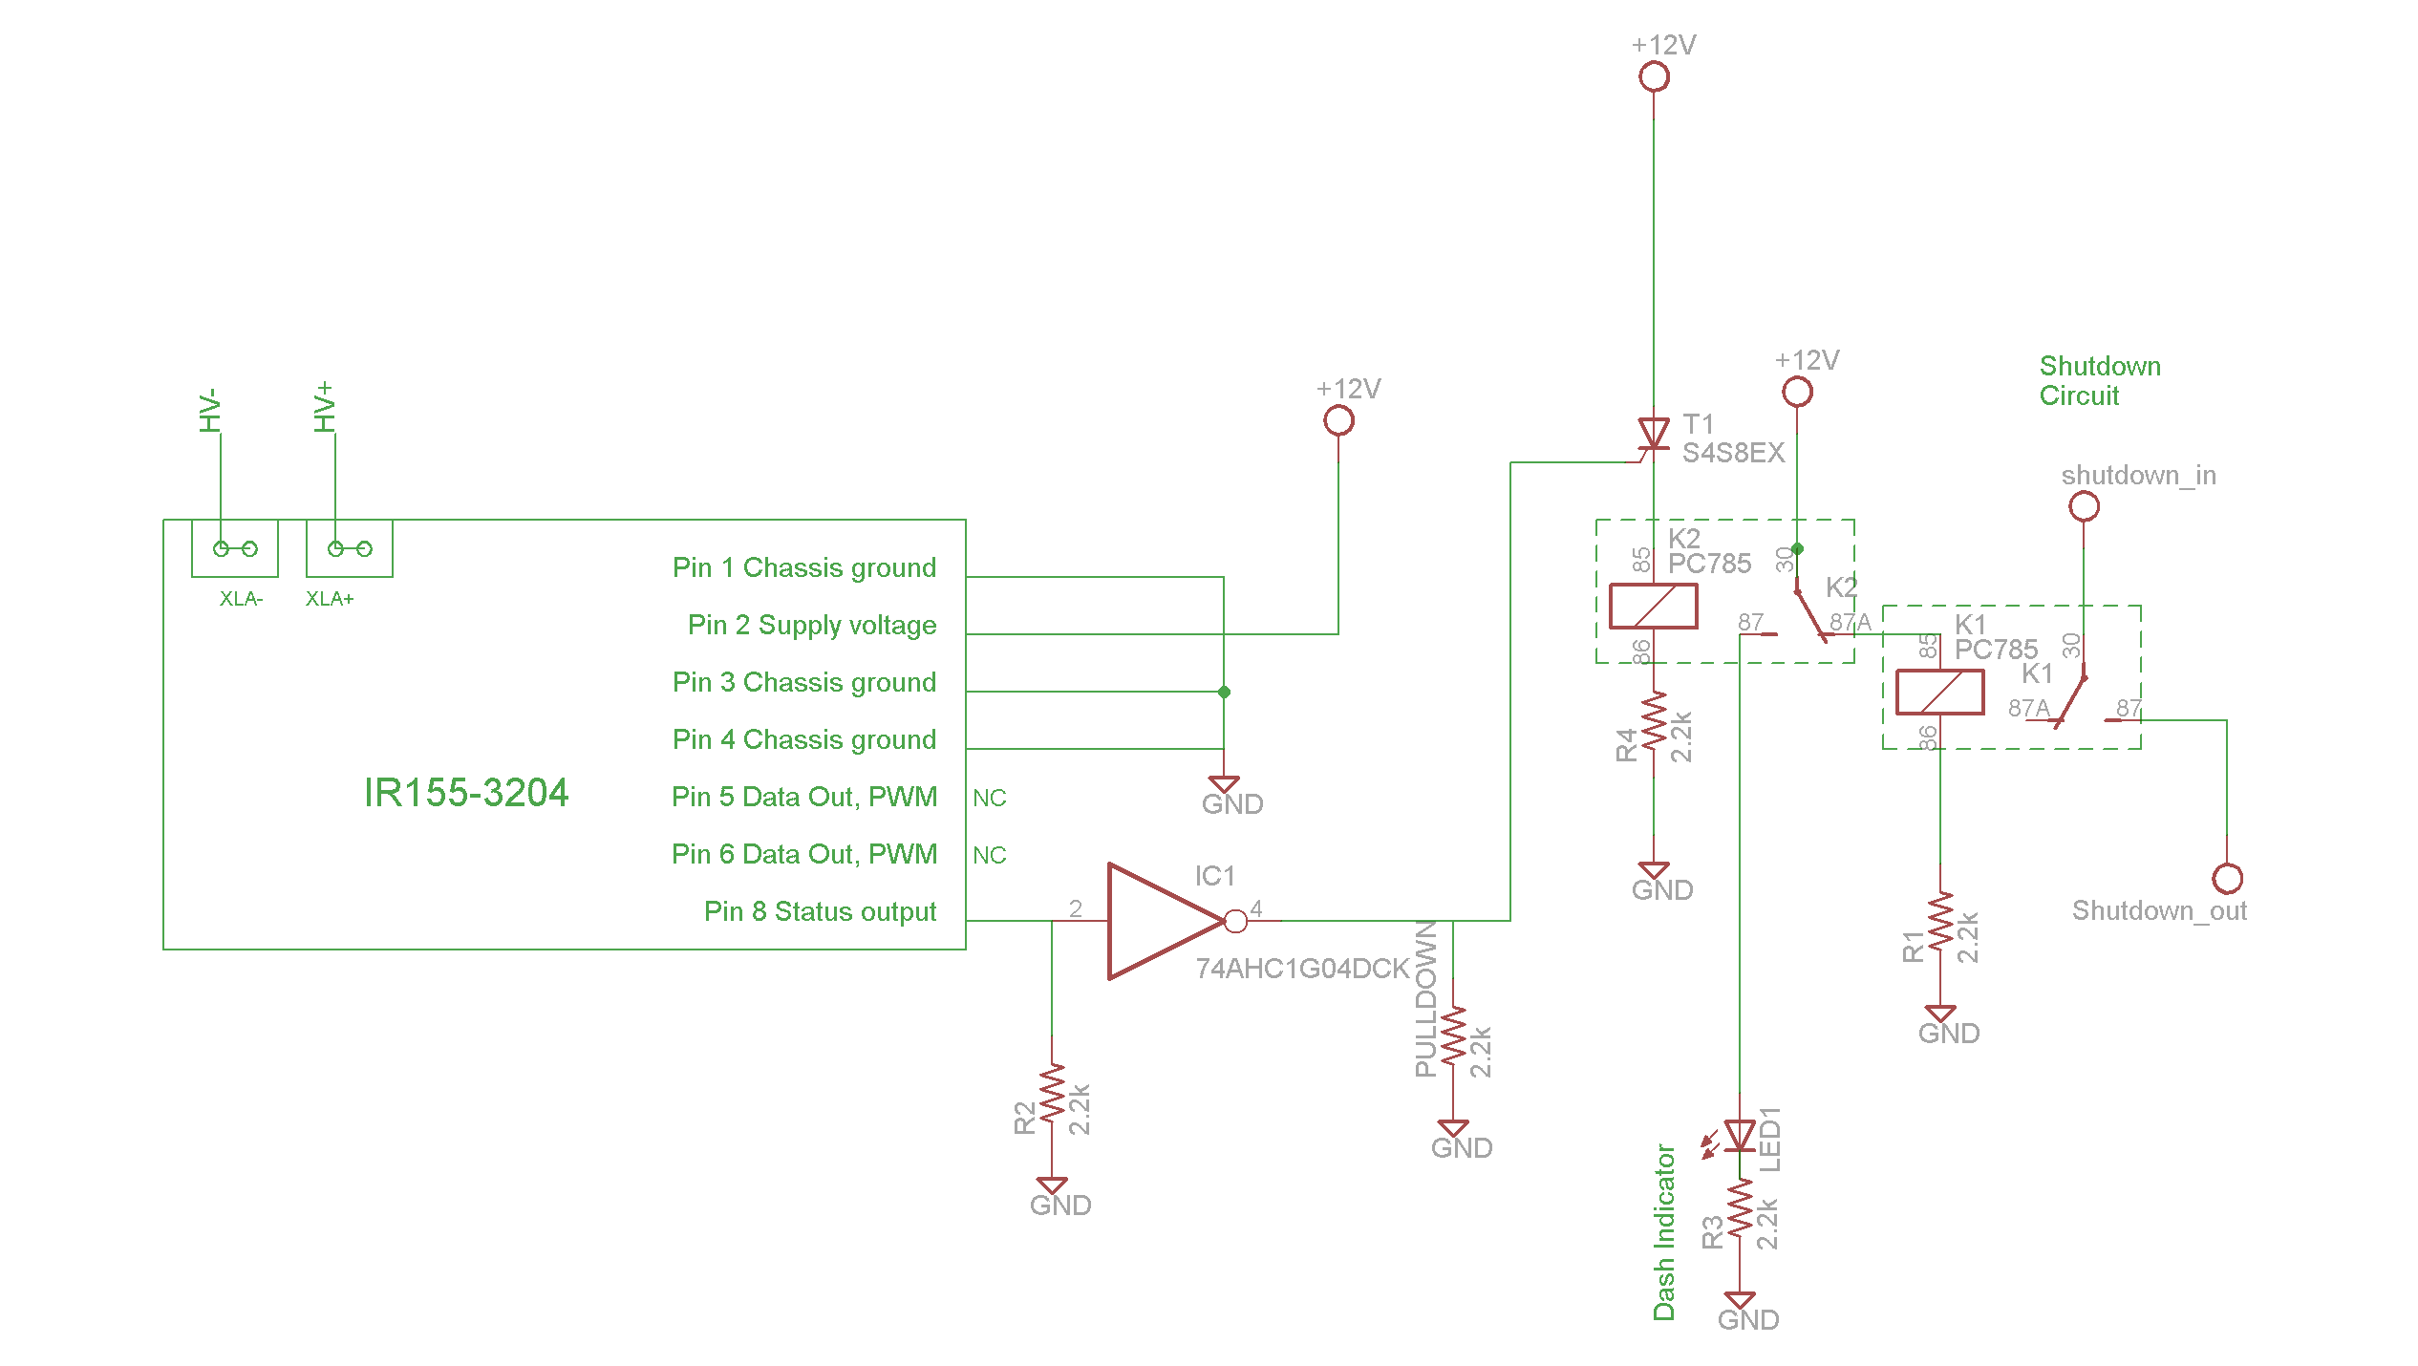

Figure 2‑3 IMD circuit schematics. The last portion of the circuit (relay K1) directly controls the shutdown circuit from Figure 2‑1

### Position in car

IMD is located in the lower accumulator container, as shown in Figure 2‑4. More information about the accumulator container can be found in section Accumulator pack 1.

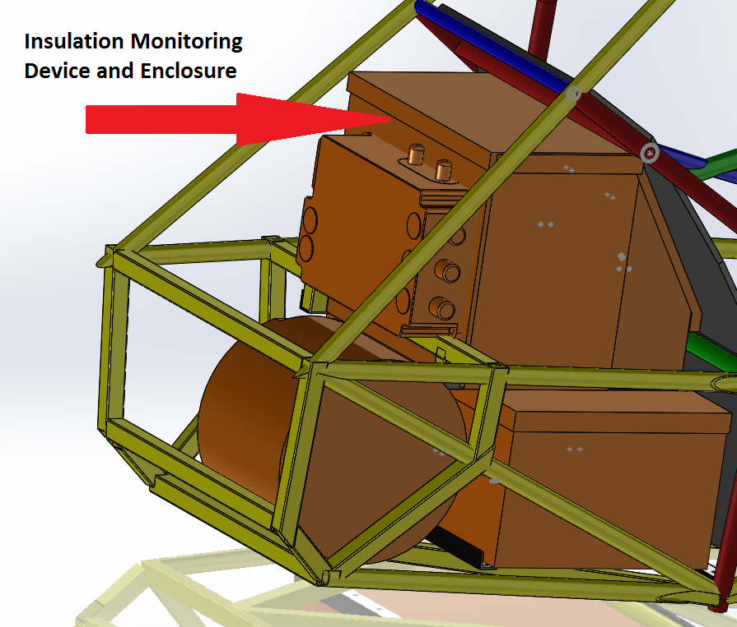

Figure 2‑4 IMD position

## Inertia Switch

### Description (type, operation parameters)

The inertia switch is a First Technology Resettable Crash Sensor, rated at opening the circuit at 10 g or more of deceleration.  It is in series with the shutdown circuit, and upon impact, it will activate the circuit and open the AIRs, stopping current flow. The inertia switch will remain open until the button is manually pressed, closing the circuit. Our inertia switch is mounted on close to the driver’s dash (see Figure 2‑5). It is removable to test functionality.

|  |  |
| --- | --- |
| Inertia Switch type: | First Technology resettable crash sensor |
| Supply voltage range: | 10..36VDC |
| Supply voltage: | 12VDC |
| Environmental temperature range: | -40..105°C |
| Max. operation current: | 10A |
| Trigger characteristics: | 10g for 50ms / 16g for 15ms |

Table 2‑4 Parameters of the Inertia Switch

### Wiring/cables/connectors/

The wiring used for the inertia switch is stranded 18 AWG wire. The connectors is IP65 rated Deutsch connector. It is wired in series with the shutdown circuit.

### Position in car

Mounted vertically to the front roll hoop as shown in Figure 2‑5.

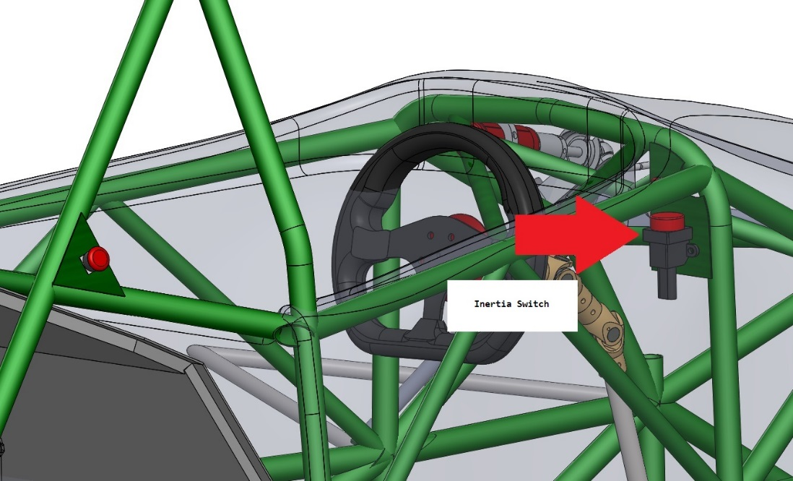

Figure 2‑5: Inertia switch location drawing

## Brake Plausibility Device

### Description/additional circuitry

The brake system plausibility device (BSPD) is a standalone non-programmable circuit that opens the AIRs on the tractive circuit during hard braking if there is positive current flow that results in over 5 kW of power from the motor controller to the motor.

Current = I = P/V = 5000 W/196V >= 25.5 A

We are using a [hall effect current sensor CSLA1CD](http://sensing.honeywell.com/index.php/ci_id/49794/la_id/1/document/1/re_id/0), It has range of 57A, so at 25A it is at half of its range. The offset voltage is at Vcc/2 = 12/2 = 6V at zero current. Because the sensor is bi-directional, it will sense 71% of Vcc at 25A = 8.6V and the equation is $V_{sense}=(6+\frac{57}{25}*0.5)*V_{cc}/2$

The sensor is located in the main contactor box, and is sensing DC current entering the motor controller. Indeed the max current is higher than the range of the sensor, but that is OK since the sensor will just saturate at DC current over 57A.

A brake pressure switch is used as the braking input signal. If the brake is pressed hard[1] it will close the circuit and pull it low (Logic 0). The brake plausibility utilizes [LM2903 dual differential comparator](http://www.ti.com/lit/ds/symlink/lm2903-q1.pdf) (designed for automotive applications), and has two stages. In the first stage, we compare the signal from current sensor V_in with V_ref = 8.6V. If V_in > V_ref the output of the comparator will be Logic 0. This logic output is then passed through an AND gate with brake pressure sensor. Hence if (BRAKE==LOW && V_in > V_ref) => output=HIGH

To introduce desired delay of 0.5s in the circuit we use the second channel of the linear comparator and make a delay RC circuit. Essentially one input of the comparator is V_ref2 = ~90% V_cc, the other input is Logic output from the AND gate but delayed with the RC circuit.

We don’t know the exact values of all resistors, but this setup will make sure there is sufficient delay in the system. The output of the second channel is then ANDed with the output of the first channel, and fed into BSPD relay, so it can open shutdown circuit if necessary.

|  |  |
| --- | --- |
| Brake sensor used: | Pegasus Hydraulic Brake Light Switch |
| Torque encoder used: | potentiometer |
| Supply voltages: | 12V |
| Maximum supply currents: | 1A |
| Operating temperature: | -20..180 °C |
| Output used to control AIRs: | on/off style binary voltage switch |

Table 2‑5 Brake switch data

### Wiring

The functionality was described above, the wires are standard 18AWG, plus the circuit is on a PCB, enclosed in waterproof box. Schematics of the circuit is shown in Figure 2‑7. Figure 2‑6 shows the PCB layout.

### Position in car/mechanical fastening/mechanical connection

The brake pressure transducers are mounted in the brake lines, and the voltage signal varies with different pressures. The current sensor is in the main contactor box, the BSPD itself is located next to the accumulator container. The location is shown in Figure 2‑8 and close up view is shown in Figure 2‑9.

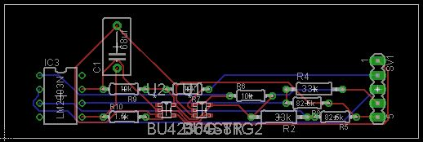

Figure 2‑6 BSPD PCB layout

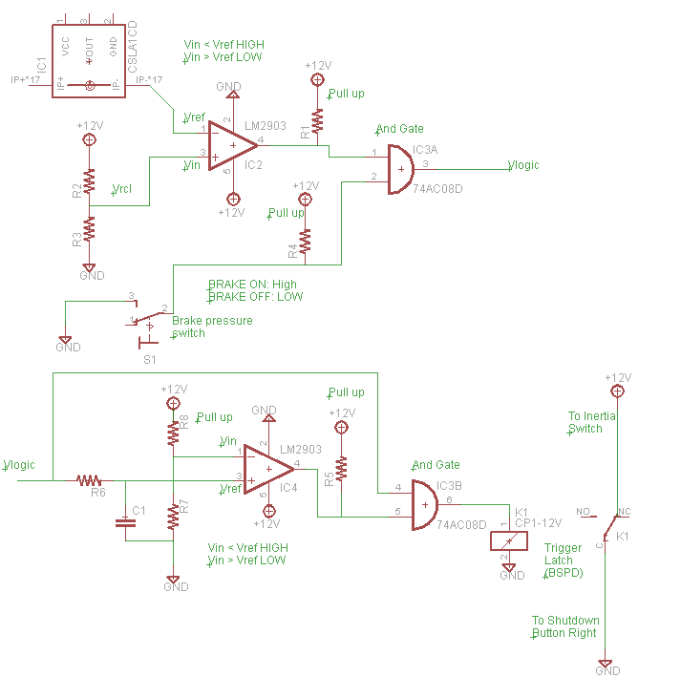

Figure 2‑7 BSPD schematics

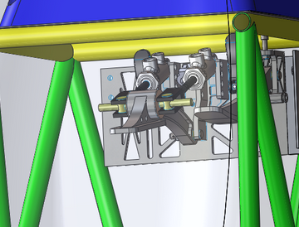

Figure 2‑8 Placement of the brake pedal and the master cylinder

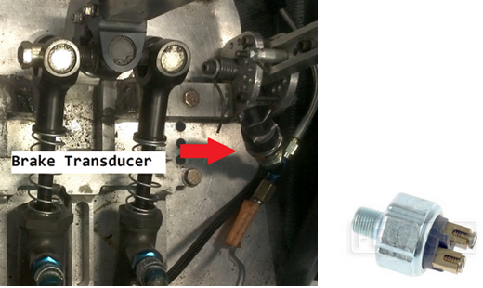

Figure 2‑9 Brake switch and its location

## Reset / Latching for IMD and BMS

### Description/circuitry

Our latching circuit will consist of 3 relays. One for the IMD one for the BMS and one to turn off the entire system. This is accomplished with thyristor and relays. For the BMS, the shutdown circuit automatically opens if there is an overvoltage, undervoltage, or overtemperature conditions. For the IMD, in the case of a fault, too low insulation resistance, IMD error, ground error, undervoltage detected or IMD off, the shutdown circuit opens. In the event of the circuit opening, it will not close again until it is manually reset by switching off and on the GLV Master switch (effectively cutting power to all LV circuits), and this can only be done by someone outside of the race car.

### Wiring/cables/connectors

IMD latching circuit is shown in Figure 2‑3, BMS latching circuit is identical, but is controlled by BMS – see Section 8.1 for details.

### Position in car

The latching circuits are located In an enclosure placed on the left side of the top accumulator container, below HVD and next to VCU – see Figure 8‑5 for details.

## Shutdown System Interlocks

### Description/circuitry

Interlocks are circuits used to open the shutdown circuit if a connector is disconnected or an enclosure is open. We are using interlocks on all of our HV wiring that comes out of the accumulator containers.

Top accumulator has one interlock on HVD, and one for HV connector that goes to the bottom accumulator. The bottom accumulator has one interlock on HV connector that comes from the bottom accumulator, one on HV connector that goes to the motor controller and one on TSMP connectors.

### Wiring/cables/connectors

Wiring is shown in Figure 2‑10. 12V from TSMS enter the top accumulator via 4pin Deutsch DT connector. Internally the shutdown circuit connects both AIRs and then goes to HVD (see Section 2.11 for details), and HV connector (Imperium™ High Voltage/High Current (HVHC) Connector System, see Figure 11‑5 for receptacle and Figure 11‑6 for header). HVHC connector has an internal interlock, which closes the circuit when the connector is plugged in. TSMP connector is Amphenol 6pin DIN connector (see Figure 11‑1 for details). Note that although the connector has 6 pins, we are using only 2 pins HV+, HV- and two for interlocking mechanism. All wiring is 18AWG.

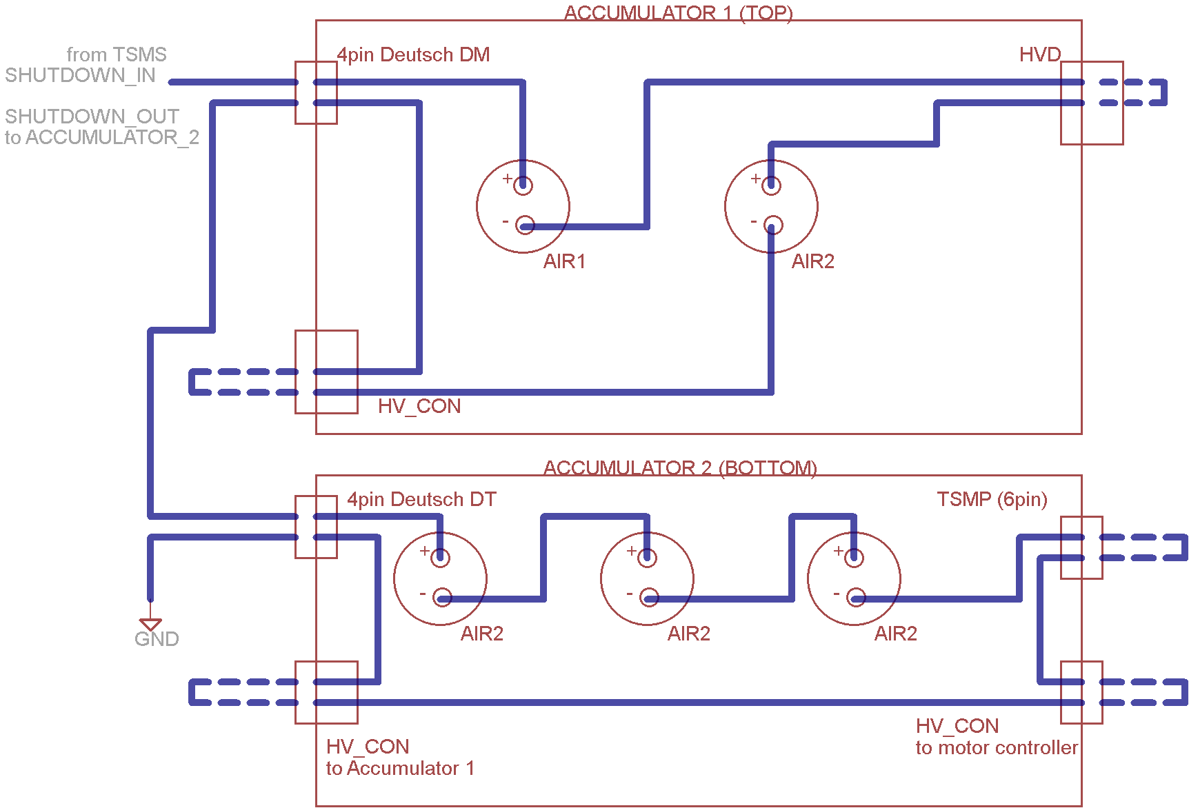

Figure 2‑10 Inerlocks wiring diagram. Removable part of the interlock is dashed

### Position in car

Interlocks are located on sides of the battery containers, please refer to Section 3 for details.

## Tractive system active light

### Description/circuitry

The tractive system active light (TSAL) is LED lights, red in color, and flashes at a frequency of ~3 Hz.  It is clearly visible 360 degrees around the entire car when the tractive system is activated.  Each light is 12 lumens, bright enough to be clearly visible by a person standing 3 meters away from the TSAL.  It is the only light located anywhere near that area.  The 3 Hz frequency is created by TSAL circuitry (basically 555 timer and two transistors). The light is provided by red waterproofed LED strip, that is powered by 12V and is cut to size.

TSAL is placed in cylindrical enclosure under the main roll hoop. Inside the enclosure is also RTDS buzzer. The enclosure is 3D printed, consists of two parts that are glued together, as shown in Figure 2‑11.

|  |  |
| --- | --- |
| Supply voltage: | 12VDC |
| Max. operational current: | 700mA |
| Lamp type | LED |
| Power consumption: | 4.5 W |
| Brightness | 100 Lumen |
| Frequency: | 3.2Hz |
| Size (length x height x width): | 3” x 1.5” x 1.5” |

Table 2‑6 Parameters of the TSAL

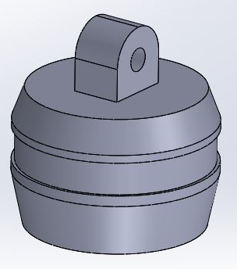

Figure 2‑11 TSAL & RTDS enclosure drawing

### Wiring/cables/connectors

HV+ lead is connected on the motor side of the main contactor, and HV- is connected on most negative lead.  When the precharge circuit has completed, and the main contactor closes, tractive system voltage is at ~196 VDC max. There is a zener diode at the HV+ input, preventing voltages < 60 V to activate circuit. LR8 high voltage linear regulator provides power to ILD74 optocoupler, which separates HV and LV. Timer 555 is powered by 12V and takes care of periodical switching of the transistors. That way we can switch larger loads necessary to power the lights.  We tested the circuit and it provides satisfactory results. The wiring diagram is shown in Figure 2‑12, the PCB layout is shown in Figure 2‑13.

Running Vout trace between Vin and Vref pins is not a concern, since all traces are covered by top layer. On top of that, we cover whole board with a layer of conformal coating to protect the PCB from corrosion, provide insulation resistance, and possible shorting.  We will be using an [Acrylic Conformal Coating 419C](http://www.mgchemicals.com/products/protective-coatings/conformal/acrylic-conformal-coating-419c/) to achieve this.The dielecric withstand voltage value is >1500V which is sufficient for our application. Datasheet is shown in Figure 11‑8.

TSAL has 4 LV inputs (LIGHT+, LIGHT-, GND, 12V+) and two HV inputs (HV+, HV-). TSAL PCB is inside the main contactor box, with only LIGHT+ and LIGHT- 18AWG wires coming the the TSAL enclosure under the roll hoop. This way HV leads don’t have to  be outside the contactor box, making design simpler.

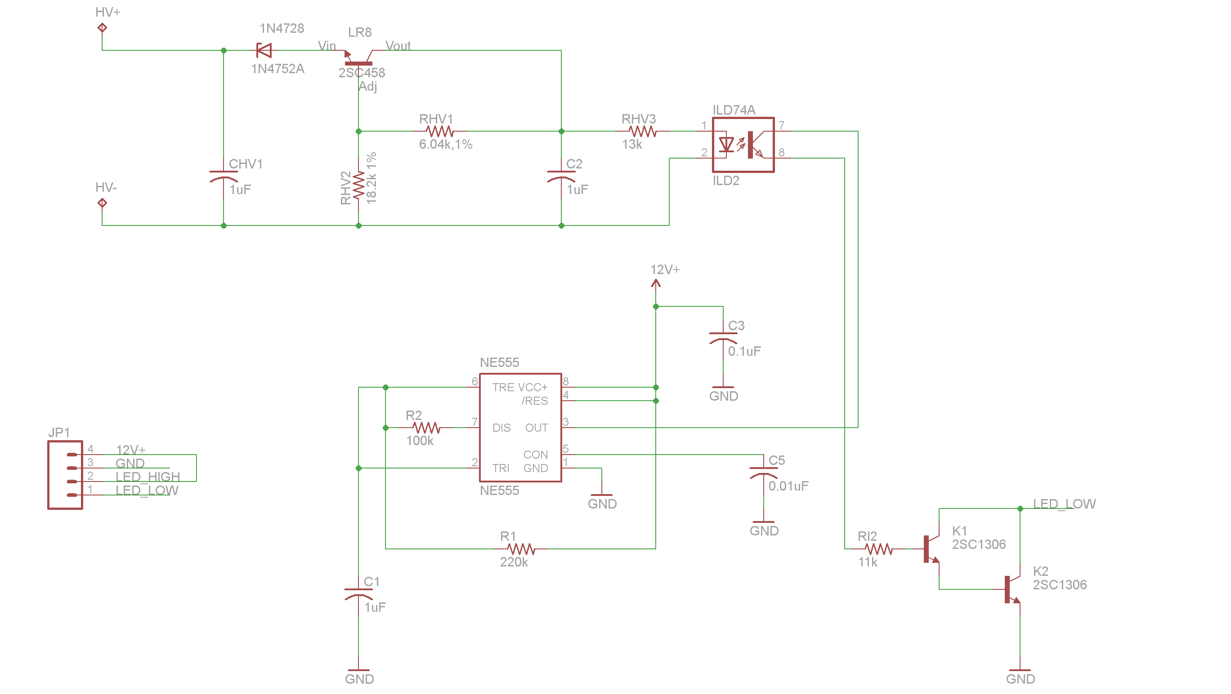

Figure 2‑12 Wiring diagram of TSAL

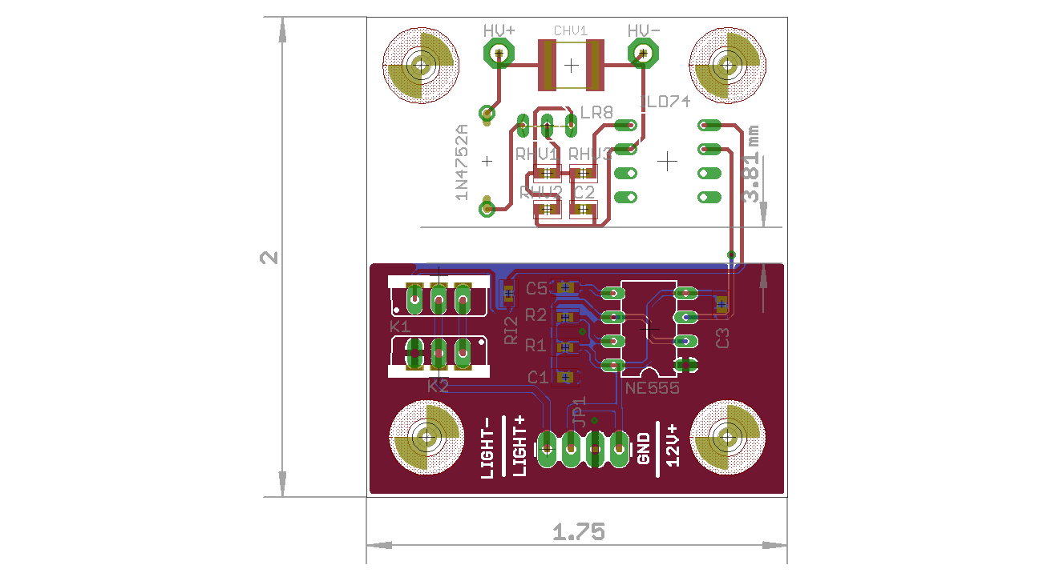

Figure 2‑13 Board Layout of TSAL (board dimensions are in inches)

### Position in car

The light is mounted on the top of the roll hoop, and is unable to contact the driver’s helmet (we measured that there is enough clearance), as shown in Figure 2‑14.

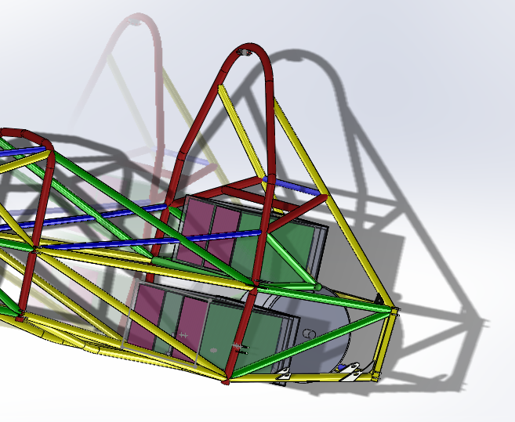

Figure 2‑14 Position of TSAL in the car, under the top of the main roll hoop

## Measurement points

### Description

Tractive system measuring points (TSMPs) are for voltage measurements, and are installed next to the master switches. They are contained in an insulated, plastic electrical box with a rubber cover to protect them from short circuiting and from the elements. The rubber cover can be pulled open to access the TSMP’s.

### Wiring, connectors, cables

The measuring points are three female banana jacks (Pomona Banana Jack, see Figure 11‑2 for details) that are mounted within the electrical box. 2 of the jacks are black, labeled HV- and GND for the Tractive system and GLVS common nodes, respectively. One red banana jack is labeled HV+ and is connected to the tractive system supply voltage. Both jacks are rated for 15A and 1000 Vrms. There are also two 5kΩ protective resistors (Welwin W24-5K-JI, see Figure 11‑3 for details) in line with the test points. They are rated at 14W and 750V. The TSMP resistors are located within the accumulator container.

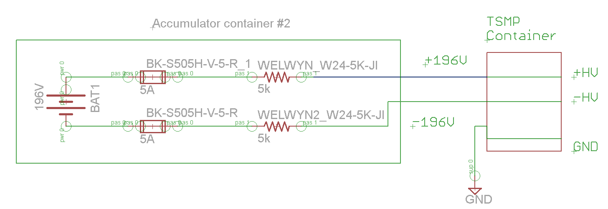

Figure 2‑15 TSMP schematics

### Position in car

TSMP are located next to the master switches on the right side of the car (looking from behind), just next to the main roll hoop, see Figure 2‑16 and Figure 2‑17.

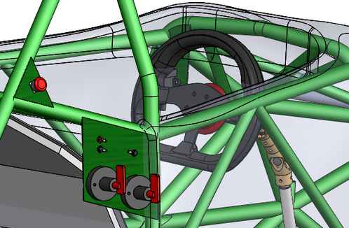

Figure 2‑16 Location of TSMP in the car

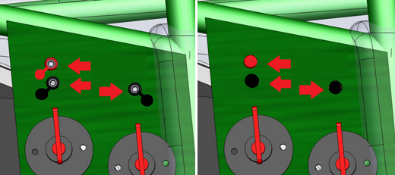

Figure 2‑17 Close of view of TSMPs with caps on and off

## Pre-Charge circuitry

### Description

The pre-charge circuit is required to charge the circuitry between the accumulators and the motor controller to 90% of the 196 VDC maximum voltage before closing the second AIR. This must be done to protect the motor controller and other components from the very large inrush current that occurs when the batteries are first connected to the controller.

The pre-charge circuit power is driven by the tractive system master switch. The motor controller has sequential input pins that require the pre-charge relay to be charged before the last AIR can close. If the shutdown circuit is open, the relay for the precharge circuit will be open. Therefore, it will open the tractive pre-charge circuit branch, and not be possible to close the tractive system circuit.

Voltage Formula: $V =I*R*e^{\frac{-t}{RC}}$

Current Formula: $I = \frac{V_{b}}{R}*e^{\frac{-t}{RC}}$

The cable used on the AIRs in the tractive system is 2 awg cable. The pre-charge relay will have a very low current flow:

I = V/R = 196/1000 = 0.19 A

The max power through the resistor will be ~39W, and a resistor derated without a heatsink can safely dissipate 50W. The resistor will be mounted with positive locking fasteners to an insulative sheet. Figure 2‑18 shows precharge voltage vs time, and Figure 2‑19 shows precharge current vs time.

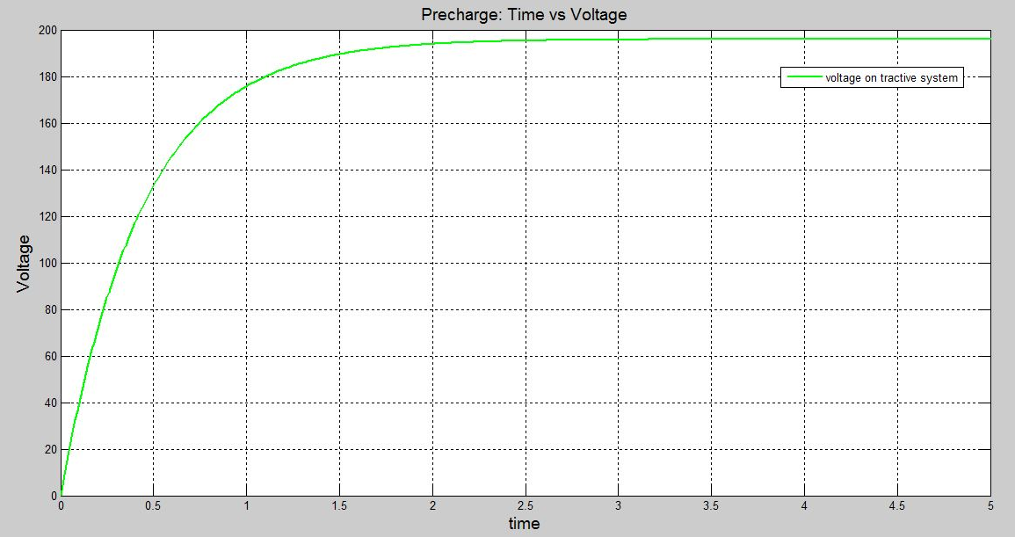

Figure 2‑18 Precharge Plot of Percentage Maximum Voltage vs. Time

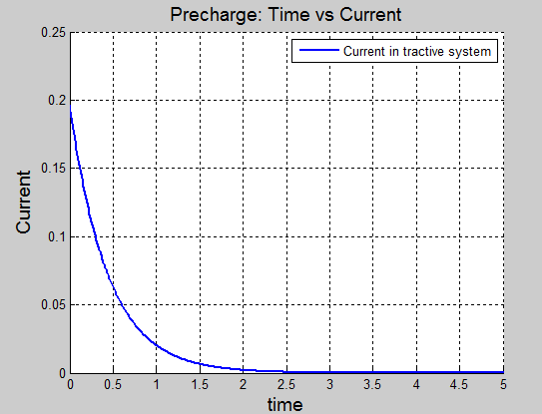

Figure 2‑19 Precharge Plot of Current vs. time

### Wiring, cables, current calculations, connectors

Schematics of the pre-charge circuitry is shown in Figure 2‑1. The wiring used in the shutdown circuit is 18 AWG stranded, shielded wire. The wire is colored orange. Table 2‑7 and Table 2‑8 give basic information about the pre-charge circuit. We are using Solid State Relay for pre-charge.

|  |  |
| --- | --- |
| Resistor Type: | TE wirewound chassis mount |
| Resistance: | 1 kΩ |
| Continuous power rating: | 100W, 50W without heatsink |
| Overload power rating: | 2500W |
| Voltage rating: | 1900 VDC |
| Cross-sectional area of the wire used: | 0.823 mm² (18 AWG) |

Table 2‑7 General data of the pre-charge resistor

|  |  |
| --- | --- |
| Relay Type: | Gold SDP4020D |
| Contact arrangment: | SPST-NO |
| Continuous DC current: | 20 A |
| Voltage rating | 280 VDC |
| Cross-sectional area of the wire used: | 0.823 mm² (18 AWG) |

Table 2‑8 General data of the pre-charge relay

|  |  |
| --- | --- |
| Fuse type: | Bussmann/Eaton |
| P/N: | FWH-005A6F |
| Continuous current rating: | 5A |
| Maximum operating voltage | 500 VDC |
| Type of fuse: | Fast Blow |
| I2t rating: | 15 pre-arc, 40 clearing |
| Interrupt Current (maximum current at which the fuse can interrupt the current) | 50 kA |

Table 2‑9 Basic fuse data

### Position in car

Pre-charge relay is located in the lower accumulator container, see Section 3 for details.

## Discharge circuitry

### Description

The discharge circuit allows energy stored in the motor controller’s to be discharged after the tractive system is shut down. The circuit consists of a normally closed relay in series with a dissipation resistor, setup to discharge the maximum high voltage across the motor controller’s internal capacitor. When the system is powered on, the relay opens and the system operates as normal. When the shutdown system is off, the open, and when the HVD is removed, the discharge circuit is closed, and the discharge resistor will discharge energy to less than 2V in 5 seconds.

### Wiring, cables, current calculations, connectors

Basic information of the discharge circuit is shown in Table 2‑10. Fuse and relays are identical to those used in pre-charge circuit, please refer to Table 2‑8 and Table 2‑9 for details. Discharge circuit current vs time is shown in Figure 2‑21, plot of voltage vs time is shown in Figure 2‑20. The schematics of discharge circuit can be found in Figure 2‑1.

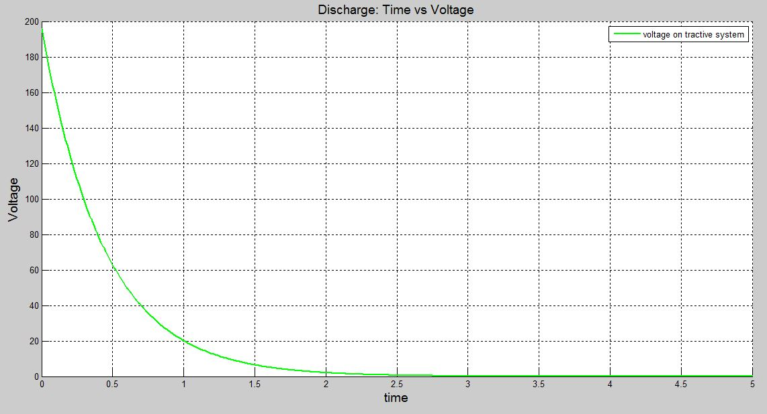

Figure 2‑20 Dicharge circuit voltage vs time

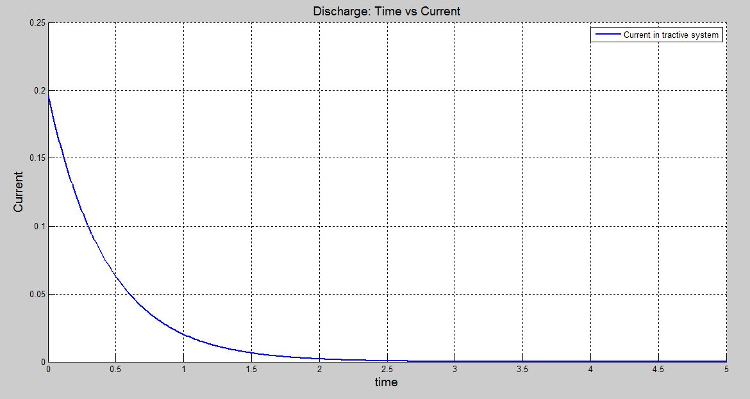

Figure 2‑21 Dicharge circuit current vs time

|  |  |
| --- | --- |
| Resistor Type: | TE wirewound chassis mount |
| Resistance: | 1 kΩ(HSC) |
| Continuous power rating: | 100W, 50W without heatsink |
| Overload power rating: | 2500W |
| Voltage rating: | 1900 VDC |
| Maximum expected current: | 0.197 ADC |
| Average current: | 0.07 ADC |
| Cross-sectional area of the wire used: | 0.823 mm² (18 AWG) |

Table 2‑10 General data of the discharge circuit

### Position in car

Discharge relay is located in the lower accumulator container, see Section 3 for details.

## HV Disconnect (HVD)

### Description

The vehicle uses one TE AMP+ Manual Service Disconnect (see Figure 11‑4 for details). The HVD is 360 mm above the ground, orange with an interlock, and well-marked. HVD can be opened without any tools, and when released, first is opened interlock and then the HV circuit. This way the AIRs have chance to deenergize before breaking the HV circuit.

### Wiring, cables, current calculations, connectors

HVD is in series with remaining interlocks within the shutdown circuit. When opened, it interrupts the current path from the positive pole. Wiring is shown in Figure 2‑22.

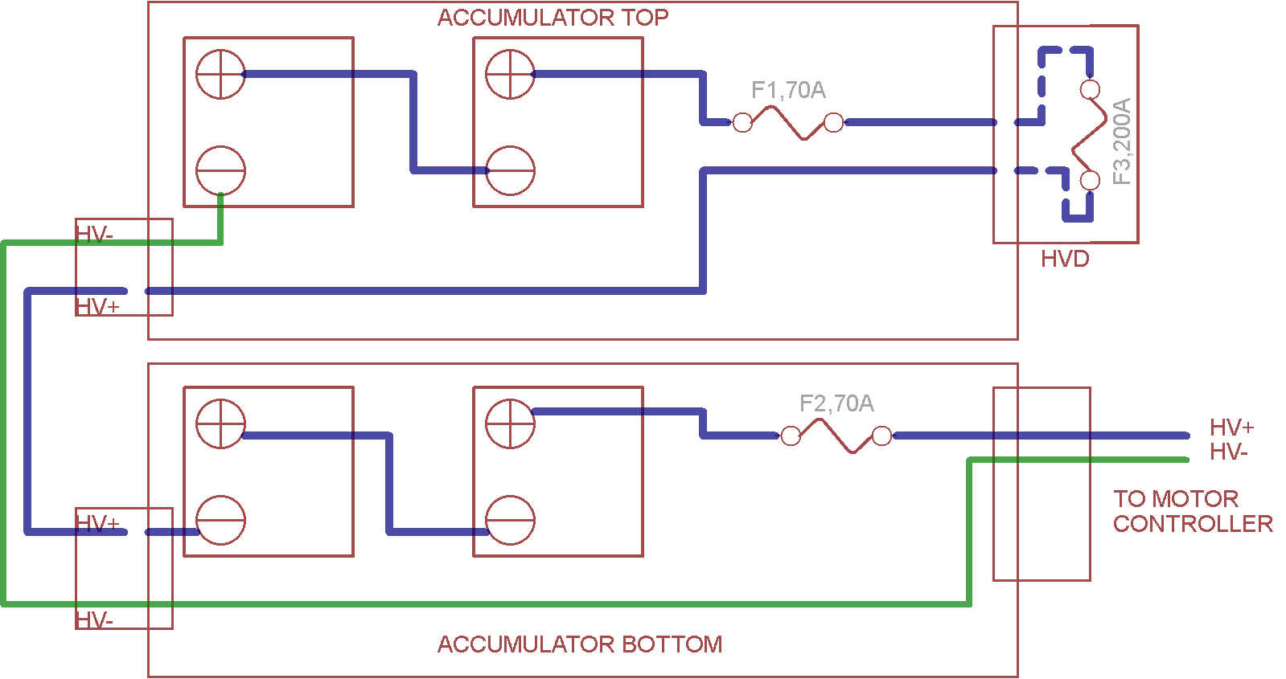

Figure 2‑22 HVD wiring, LV wires ommited for clarity. Blue is HV+, Green is HV-, HVD located in top accumulator container

### Position in car

HVD is located on the left side of the upper accumulator container, as shown in Figure 2‑23.

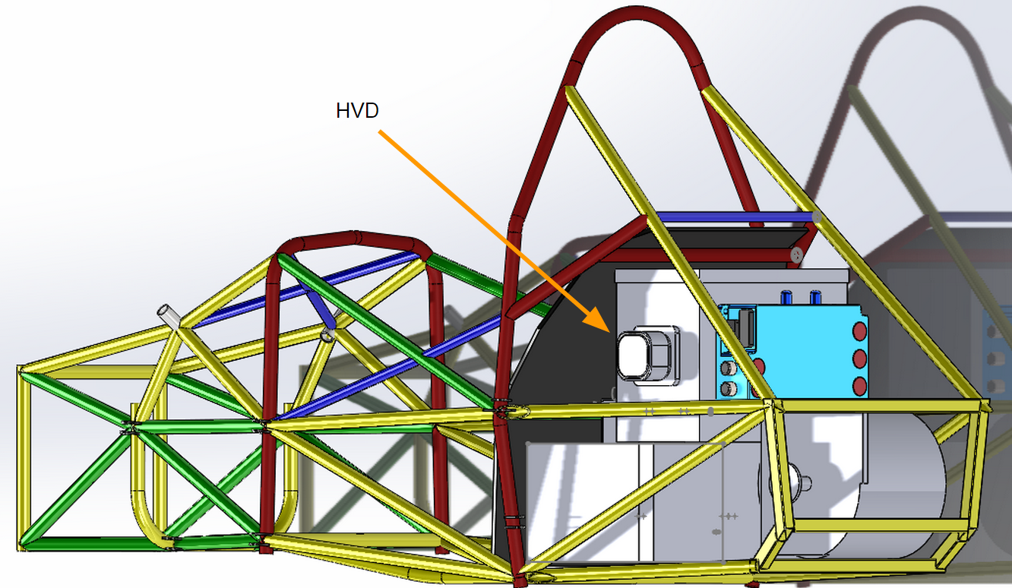

Figure 2‑23 HVD location on the left side of the top battery box

## Ready-To-Drive-Sound (RTDS)

### Description

The RTDS is a sustained 3 kHz tone emitted at 80 dBA for 2 seconds. One buzzer will be used, and will have max 75 mA current supplied by the 12V battery.  This indicates the tractive system is on, and the precharge circuit has completed, and the vehicle is ready to drive and will be propelled once the driver presses the accelerator pedal. We are using **PUI Audio AI-5025-TWT-R buzzer**.

Once the motor controller changes its state into “Ready-to-drive”, the Vehicle Control Unit (VCU) reads its state over CAN and triggers the “Forward Enable” switch on the motor controller (J1-30)  as well as RTDS circuit (using the enable pin on the buzzer).

The car can be set to Ready-to-Drive mode by applying the following steps:

1. switch on Tractive System Master Switch
2. switch on Low Voltage Master Switch
3. The motor controller will initiate precharge and if the voltage at the controller DC HV inputs is higher than 100V after 4 seconds of precharge, it will close main contactor
4. The motor controller is in standby mode now
5. Driver has to press simultaneously brake pedal and flip the FORWARD_ENABLE switch to ON set the vehicle into Ready-to-Drive mode

If any of these points are not met, the car cannot go into ready to drive mode.

### Wiring, cables, current calculations, connectors

The RTDS will be powered by the 12V grounded low voltage system, have a 75 mA maximum current, and is controlled by the VCU. The entire circuit will use 18 gauge wire. The circuit is shown in Figure 2‑24.

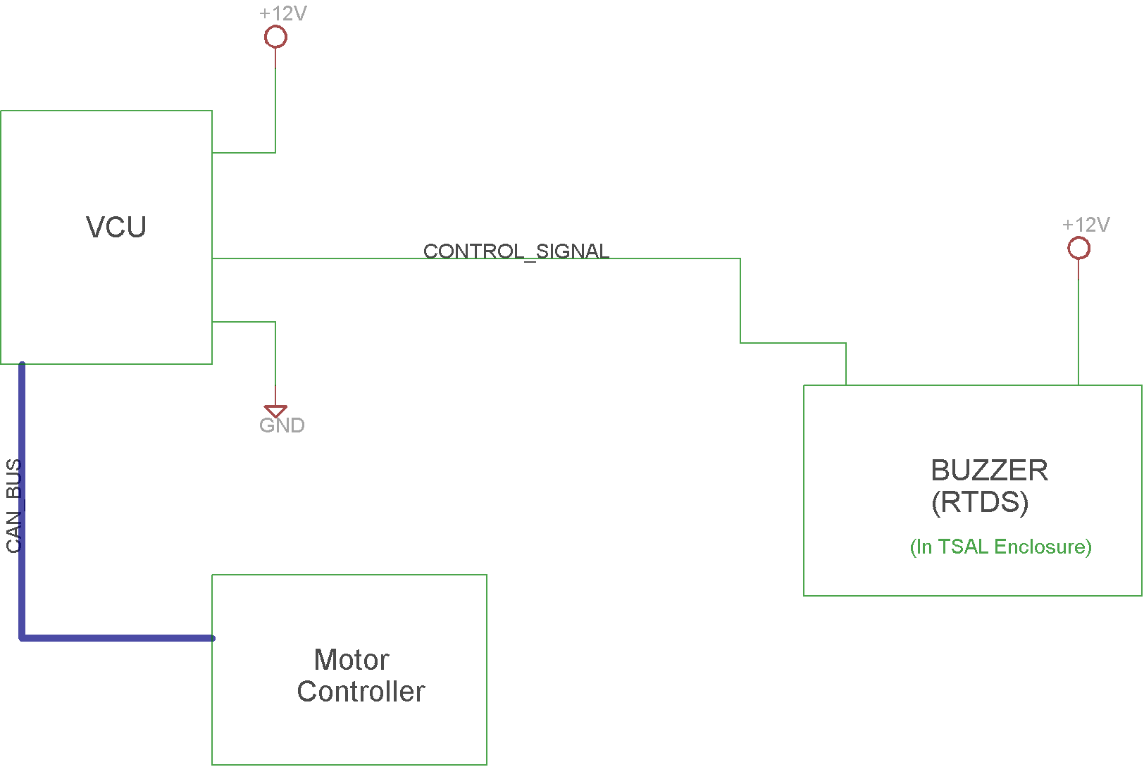

Figure 2‑24 Wiring diagram of RTDS (VCU’s digital output is „sinking current“, see Section 8.1 for details)

### Position in car

The buzzer (which is basically the whole circuit) is placed together with TSAL in the oval enclosure under main roll hoop. That way the sound will be loud and clear. The position of the RTDS circuit is shown in Figure 2‑14.

# Accumulator

## Accumulator pack 1

### Overview/description/parameters

Our accumulator design is based on [EnerDel CE 175-360 Moxie+ Prismatic Cell](http://www.enerdel.com/specsheets/energystorage/CE175-360-Moxie+-Prismatic-Cell__Final.pdf) Each of these cells has a capacity of 17.5Ah, and nominal voltage of 3.6V. We are using these cells organized in **battery modules.** We are using [ME350-049Moxie+Battery Modules](http://www.enerdel.com/specsheets/energystorage/ME350-049-Moxie+-Battery-Module_Final.pdf) that 12 cell pairs (12S-2P) and total capacity of 35Ah. The terminals on these modules have a positive locking mechanism, they are Radsok terminals that push down in place onto a hollow cylinder terminal on top of the modules (Radsok terminal datasheet).

|  |  |
| --- | --- |
| Maximum Voltage: | 98.4 VDC |
| Nominal Voltage: | 86.4 VDC |
| Minimum Voltage: | 60.0 VDC |
| Maximum output current: | 105 A for 10s |
| Maximum nominal current: | 70 A |
| Maximum charging current: | 70 A |
| Total numbers of cells: | 48 |
| Cell configuration: | 24s2p |
| Total Capacity: | 3.02 kWh |
| Number of cell stacks < 120VDC | 2 |

Table 3‑1 Main accumulator parameters

### Cell description

The cells are Enerdel 17.5 ah prismatic pouch style cells with a hard carbon anode, and a cathode of lithium nickel manganese cobalt oxide ions, and an electrical separator in between to prevent short circuits. Each cell is capable of discharging up to 3C during a pulse discharge, 2C during a continuous discharge, and charging at 2C. There is a foam sheet in between each cell in the modules, and this helps to stabilize the module by applying a uniform pressure across the cell surface. The exterior pieces on the outside of the cell module are made of plastic that is UL-94 fireproof material.

|  |  |
| --- | --- |
| Cell Manufacturer: | Enerdel |
| Cell Model: | CE175-36 |
| Cell nominal capacity: | 17.5 Ah |
| Maximum Voltage: | 4.1 V |
| Nominal Voltage: | 3.60V |
| Minimum Voltage: | 2.5V |
| Maximum output current: | 52.5A (10 seconds) |
| Maximum nominal output current: | 35A |
| Maximum charging current: | 35A |
| Maximum Cell Temperature (discharging) | 65°C |
| Maximum Cell Temperature (charging) | 55°C |
| Cell chemistry: | LiNiMnCo |

Table 3‑2 Main cell specification

### Cell configuration

The cells are flat rectangles with terminals on sides, and are then assembled in pairs (called also “subpacks”) with plastic tab separating them, as shown in Figure 3‑1. Twelve of these cell packs are then connected together to form 12S-2P battery module.

Each module is configured with 2 cells in parallel and 12 in series (12s2p). The cells in parallel share the same bus bar and all connections. Each module is packaged in series with another identical module to form one battery pack. 2 battery packs in series comprise the entire accumulator system. The cell modules use a positive locking, 6.0 mm radsok terminal rated at 160A. The high current connections between cells are made with bus bars, and from module to module, the radsok terminals make connections. The maintenance plug used are just AIRs, no manual switches are used.

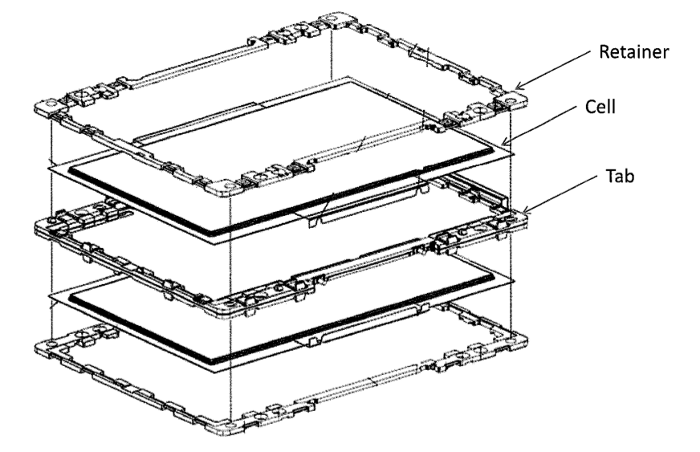

Figure 3‑1 Cells assmbled into cell pack of two (2 parallel)

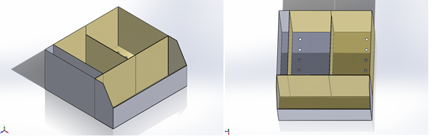

Figure 3‑2 Battery module placement within the accumulator container

### Cell temperature monitoring

Cell temperatures are monitored by the RLEC BMS. There are 4x RLEC boards, one per battery module, each monitoring 12 thermistors within the module. There are a total of 48 thermistors to monitor temperatures of the 96 cells used in the accumulator pack.

The thermistor used is NTC type thermistor, specifically NCP21WF104J03RA. 100k Ohm, 0802 SMD component. The thermistor is located on the flexi circuit next to the each cell pair. It is attached with thermal paste to the cell terminal. The thermistor is part of a voltage divider circuit, and as the temperature changes, so does the sensed voltage for each cell. Knowing the actual cell voltage, it is possible to calculate the cell temperature, based on the thermistor characteristics shown in.Figure 3‑3. Location of the thermistors is marked in Figure 3‑4. The cells are mounted with M8 diameter bolts that go through a sheet, through the cell stack, and into a welded nut on the bottom. A Nord-lock style lock washer holds them secure, and is robust against major vibrations.

The cell voltage monitoring has a precision of +-1mV. The precision of cell temperature is +-1 degree Celsius. The thermistor and cell connection is done via a flexi circuit, that connects the cells and the batetry management board for each module, shown in Figure 3‑5.

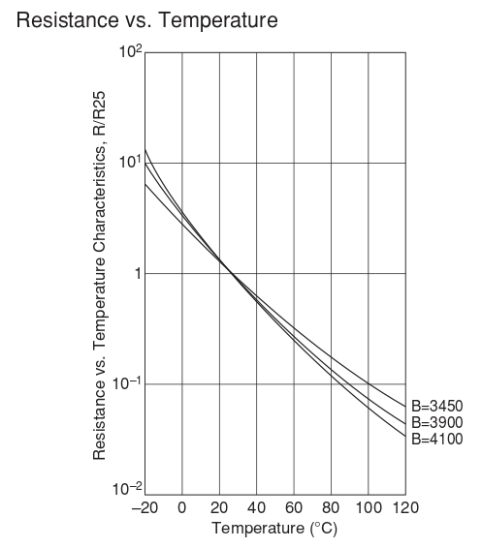

Figure 3‑3 Cell thermistor characteristics

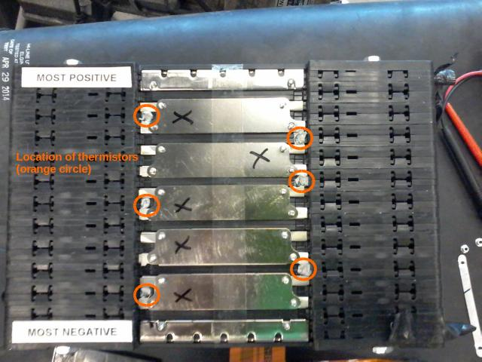

Figure 3‑4 Location of thermistors on the cell packs

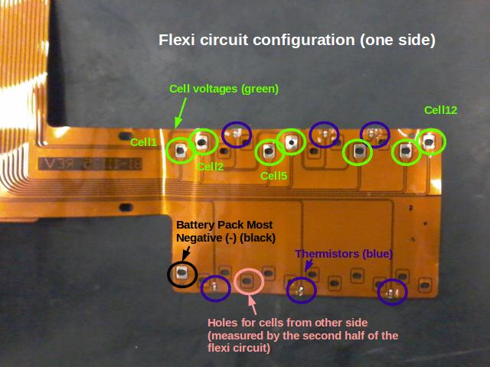

Figure 3‑5 Flexi circuit connecting cells and thermistors with the battery management board

### Battery management system

The battery management system (BMS, or AMS - both terms are used interchangeably) is a custom made system, leveraging EnerDel battery modules and Th!nk car battery monitoring boards. Each Enerdel battery module is equipped with a monitoring board called an RLEC. The RLEC board continuously monitors temperature and voltage of all cells in the module. It also monitors overall module voltage and temperature. It can also detect if a cell wire has been damaged (i.e. burned). RLEC boards communicate with BMS over dedicated and insulated CAN bus. The BMS pulls battery data from each RLEC module every 100 ms. There are total 4 RLECs (for 4 battery modules) and one BMS (in the same enclosure as VCU). The accumulators are only LiNiMnCoO2 cells, and does not include any alternative energy storage systems like supercapacitors. The hierarchy of our BMS system is shown in Figure 3‑6. BMS and MLEC is in this case equivalent.

BMS makes sure that in case there is a cell overtemperature or over/under voltage, AMS error is triggered and tractive system is shut down. BMS also controls charging. Each RLEC board has balancing resistors, so BMS can fine tune the cell voltages by switching the resistors on and off. Temperature cuttoff is 60 deg Celsius, low voltage cutoff is 2.5V per cell, and high voltage cutoff is 4.2V per cell, as recommended by the cell manufacturer.

|  |  |
| --- | --- |
| **Variable** | **Cutoff value** |
| under voltage | < 2.5V per cell |
| over voltage | > 4.2V per cell |
| over temperature | > 60 deg Celsius |

Table 3‑3 Cell cutoff values

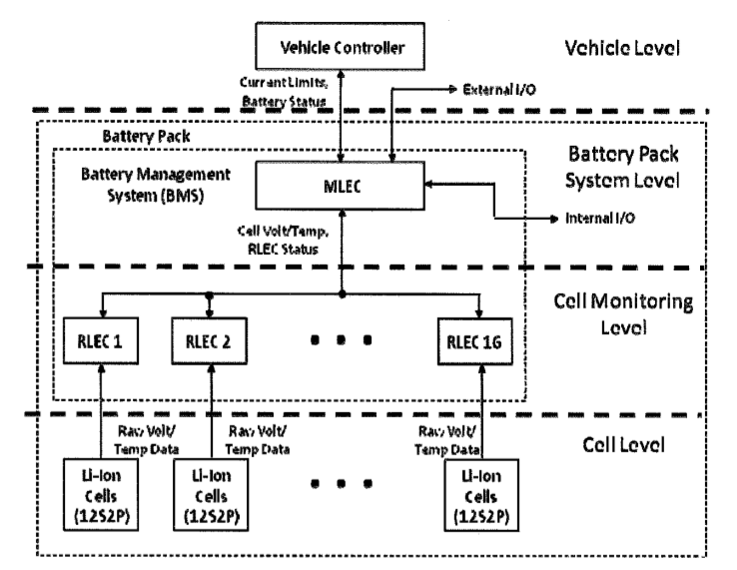

Figure 3‑6 BMS system overview

Each RLEC has 4 wires - CAN LOW, CAN HIGH, GND, 12V. The 12V input is fused by standard 10A automotive fuse. The fusible links are no required since the battery module and RLEC are professionally built and are approved for use in street legal cars. The schematics of BMS system is shown in Figure 3‑7. BMS itself is not connected to any Tractive System components, it communicates with RLECs over insulated CAN bus. And overview of RLEC capabilities is shown in Figure 3‑8:

The CAN messages from RLEC modules are marked upon arrival with a timestamp and the VCU periodically checks when was the last message received. If RLEC doesnt respond to a message request in 10 seconds, BMS will open the shutdown circuit and light up the AMS light on the dashboard. In case of a cell over temperature or cell under/over voltage the shutdown circuit is opened and AMS error light is lit.

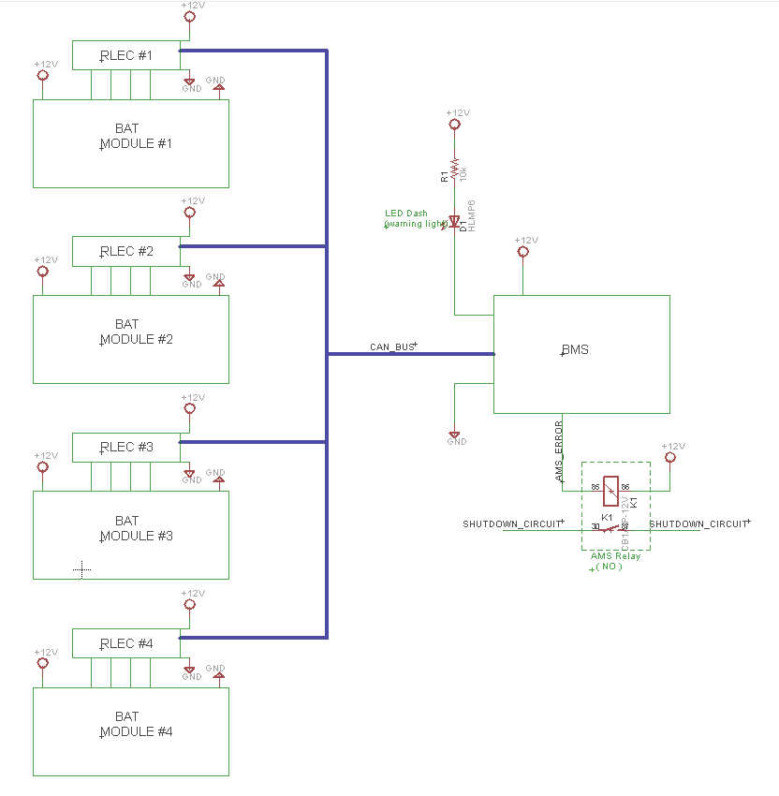

Figure 3‑7 Wiring diagram of AMS

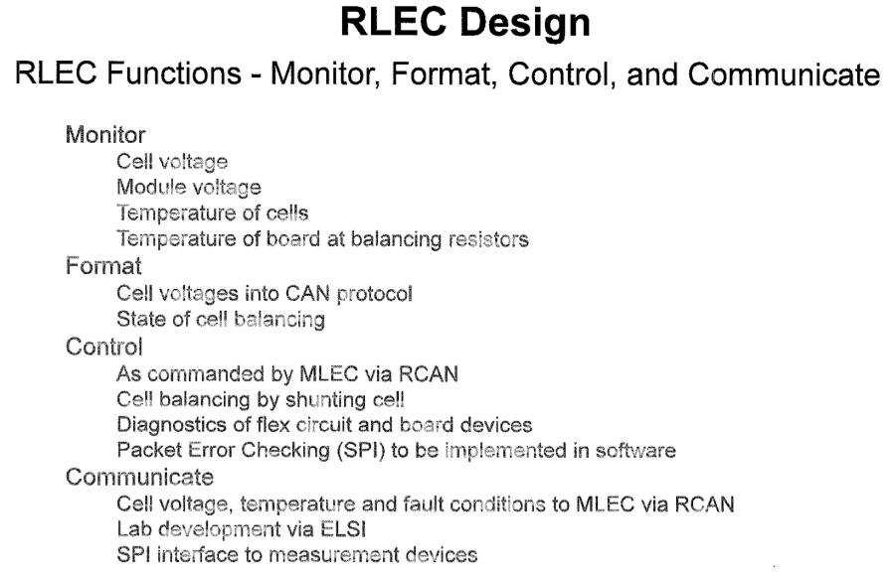

Figure 3‑8 RLEC board functions

### Accumulator indicator

The indicator will be an LED wired in with the AIR junction boxes for the battery modules. The LED will be mounted on the top of the battery module and use a lightpipe to prevent accidental contact with the tractive system voltage. The LED will be lit any time that it is providing voltage to the tractive system.

### Wiring, cables, current calculations, connectors

The accumulator indicator is basically simplified TSAL circuit - LR8 voltage regulator provides 5V when HV+ is over 60V (zener diode takes care of that), which will light up an LED. The PCB (identical to the TSAL PCB will also be covered with protective epoxy layer to prevent corrosion and unintentional shorting of exposed pads). The circuit is shown in Figure 3‑9.

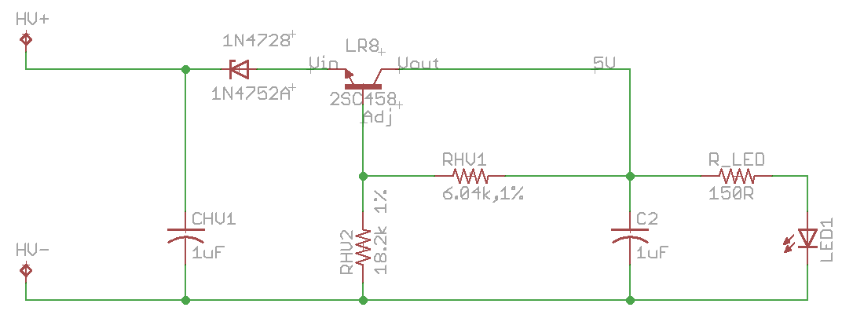

Figure 3‑9 Accumulator light schematics

|  |  |
| --- | --- |
| Wire type | Enerdel flexible pcb cable |
| Continuous current rating: | 14 A |
| Cross-sectional area | .823 mm² |
| Maximum operating voltage: | 600 VDC |
| Temperature rating: | -65 - 150 °C |
| Wire connects the following components: | cells and AMS |

Table 3‑4 Wire data for BMS connections

|  |  |
| --- | --- |
| Wire type | Super Vu-Tron |
| Continuous current rating: | 150A |
| Cross-sectional area | 21.1 mm^2 |
| Maximum operating voltage: | 600 VDC |
| Temperature rating: | -65 - 150 °C |
| Wire connects the following components: | modules and AIRs |

Table 3‑5 Cable data for battery tractive system connections²

### Accumulator insulation relays

The accumulator isolation relays (AIRs) are controlled from a 12V signal, yet are robust enough to withstand 196V, 300A and much larger inrush currents. We selected the Tyco/Kilovac EV200AAANA contactor for this application. The rated operating voltage is 900 VDC and the break current is 2000 A, both far exceed the power values required, and are far greater than the 300A fuse. There are three subpacks, and an AIR attached before and after each subpack in series. These are placed on the other side of a polycarbonate sheet that meets the UL94-VO standards.

|  |  |
| --- | --- |
| Relay Type: | Kilovac EV200AAANA |
| Contact arrangement: | 1 Form A, SPST-NO, 1 N/O |
| Continuous DC current rating: | 400 A |
| Overload DC current rating: | 500A for 10sec |
| Maximum operation voltage: | 900 VDC |
| Nominal coil voltage: | 12 VDC |
| Normal Load switching: | 500A |
| Maximum Load switching | 10 times at 1500A |

Table 3‑6 Basic AIR data

### Fusing

There is one 70A fuse in series with each pair of accumulator isolation relays on each battery sub pack. There are two battery accumulator packs with two modules (subpacks) per container. The fuse is rated in at the maximum continuous current, from the Formula Hybrid datasheet. The fuse is a [Mersen A30QS70-4](http://www.allfuses.com/media/documents/Ferraz%20A30QS.pdf) fast acting fuse. It is a single element fuse. The limiting component is the accumulator terminals with a 130A maximum continuous current rating. The operation of the fuse is along a I vs t curve, because it is based on time and current. For example, the fuse will blow in 70 seconds at 300A, or 0.01 seconds at 780A. However, this fuse protects all of the tractive system high voltage components. When the fuse blows, it opens that circuit, preventing damage to any other components. There are 2 of these fuses and they’re within the accumulator containers. The HV high current 4 AWG cables exit the accumulator containers by Molex 171466-9001 high voltage quick disconnects. The quick disconnects are an assembly with orange conduit on the cable that exits the accumulator containers.

|  |  |
| --- | --- |
| Fuse type: | Mersen A30QS70-4 |
| Continuous current rating: | 70 A |
| Maximum operating voltage | 300 VDC |
| Type of fuse: | Fast Acting |
| I2t rating: | 1.2 |
| Interrupt Current (maximum current at which the fuse can interrupt the current) | 1200 A |

Table 3‑7 Basic fuse data

### Charging

To charge the vehicle, the power will be supplied by a standard 120V outlet via an extension cord. The AC side and DC side grounds need to be electrically isolated, and this charger has this isolation in the hardware. The charger will draw 15 amps at 120 volts.

The charger is set in such way that once powered up, it will start charging at rate of 7.5 A DC (at 196V). The charger is simply controlled via charger relay, which cuts of the power (AC phase) when the battery is charged or some problem occurs. When one of the paired cells hits the maximum voltage of 4.1V, the cell is shunted, and then charging goes to another pair of cells. The voltage rating on the charger cable is 600 VDC. We will charge both accumulator containers at the same time (so they are connected in parallel) and the max voltage is thus 196V.

A normally closed emergency push button is used in series with Charger relay, so user can shut off charging at any time. Accumulator container has to be charged outside of the vehicle as required by rules, so whole charger assembly is inside a rule-compliant charging cart. The charger is connected to the accumulators via HV connector with interlock. The connector we use is Ampseal HV280 connector. The wire we are using is rated for 600V and 20A. The fuse is within the charger, so in case a short occurs, the charger automatically shuts itself down. Fuses protecting the battery packs are already present in the accumulator containers.

The charging procedure is following:

1. connect accumulator pack to the charger (it will close the interlocks)
2. power ON charger cart (that will power ON the charging cart BMS, IMD, charger and AIRS on the accumulator container)
3. charging starts automatically once charger detects HV present at its output
4. Charging will stop once max voltage (196V) is reached. The cells are continuously monitored for over temperature and over/under voltage by BMS
5. Balancing of cells can be done by closing and opening balance resistors at RLECs (controlled by BMS charging algorithm). Cell balancing is optional.

BMS will shut down both charger (Charger relay, normally open, will open AC phase supplying the charger), and AIRs (BMS relay, normally open, will open power to AIRs), in case of over/under voltage and overtemperature (same limits as for in-car BMS).

IMD will shut down power to AIRs (IMD relay, normally open), which will effectively disconnect accumulators from the charger. If Elcon charger senses no high voltage on the output, it will stop charging automatically - there will be an open circuit. Charger itself has an interlock, so an accidental removal of the HV connector will stop charging. The emergency pushdown button will stop the charger and open AIRs.

|  |  |
| --- | --- |
| Charger Type: | Elcon PFC 2500 |
| Maximum charging power: | 2.5 kW |
| Maximum charging voltage: | Input = 265 VAC Ouput = 417 VDC |
| Maximum charging current: | Input = 29 A Output = 7.5 A |
| Interface with accumulator | relays controlling AC line, no CAN |
| Input voltage: | 120 VAC |
| Input current: | 15 A |

Table 3‑8 General charger data

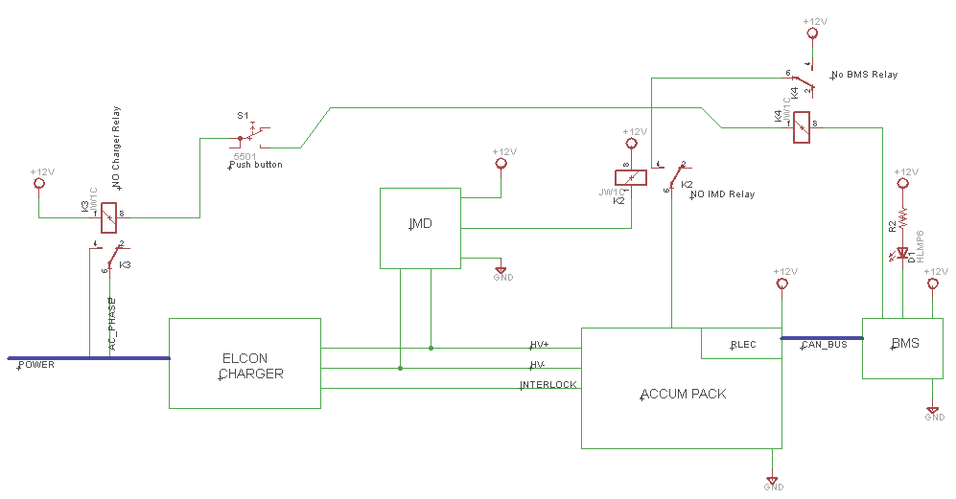

Figure 3‑10 Charger schematics

### Mechanical Configuration/materials

The battery modules which contain 12 cells each contained in a plastic enclosure. Each battery pack contains a pair of modules and is housed in a steel body. The steel body has a compartment which electronic parts such as the BMS are located. They are connected using four tie rods and covered from sides with plastic end plates. The rods have locking nuts to prevent accidental loosening. The modules are bolted through the entire module, and bolted through the floor of the battery box.

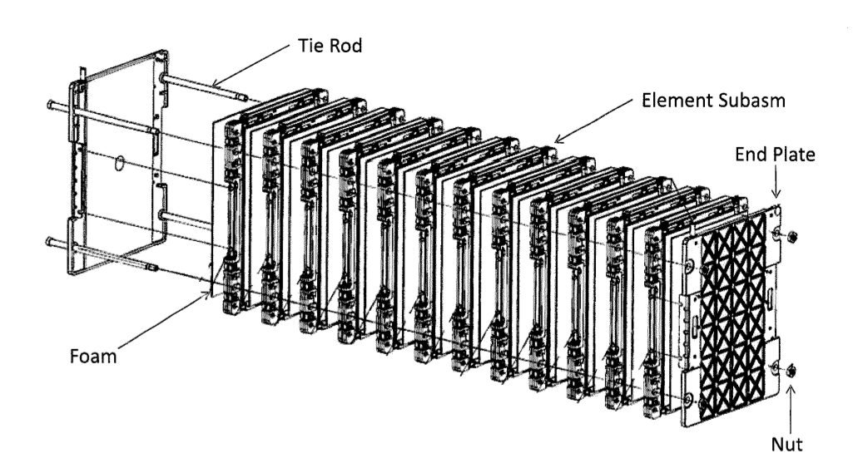

Figure 3‑11 Cells tie rod connection

To the assembled module are then added jumper tabs to connect the cells electrically. Also the flexi circuit with thermistors and cell voltage measurement points is added:

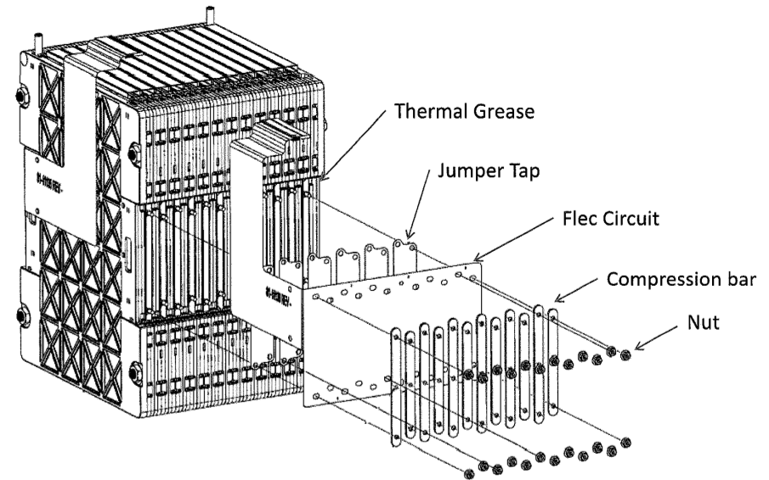

Figure 3‑12 Adding cell tabs on the assembled batetry module

In the final step, a flexi circuit connector and a plastic shield is added:

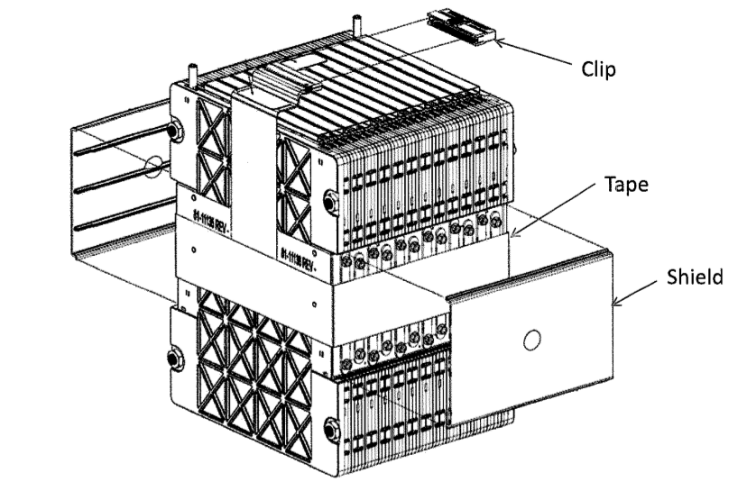

Figure 3‑13 Adding connector and plastic shields to the battery module

# Energy meter mounting

## Description

The energy meter is located in a specially designed box that will sit atop the rear battery in the back of the car. The energy meter is mounted with bolts through the bottom of it to a sheet of insulating ABS. The sheet is bolted to the bottom of the accumulator container.

## Wiring, cables, current calculations, connectors

The energy meter will have 2, mechanically crimped, 2 AWG wires connected to it. These wires are the HV+ and HV- and carry all current delivered to the motor controller and are bolted to the shunt connection. HV+ sense connection will be 18 AWG and connects to the meter with a molex connector. The GLVMS connnections are also 18 AWG and connects with a circular Harting connector, containing +12VDC and chassis ground. The fuse will be Ferraz-Mersen A30QS130-4 which is rated for 300V and 130A.

## Position in car

Energy meter is located in the bottom accumulator container, see Section 3 for details.

# Motor controller

## Motor controller 1

### Description, type, operation parameters

The motor is operated by a RMS PM100 motor controller. The motor has software onboard that varies the voltage supply to the motor based on input directly from the motor, as well as CAN messages from the vehicle control unit. Basic information is provided in Table 5‑1.

Fill out the following table:

|  |  |
| --- | --- |
| Motor controller type: | RMS PM100DX Controller |
| Maximum continous power: | 105kW |
| Maximum peak power: | 122kW for 10s |
| Maximum Input voltage: | 360VDC |
| Output voltage: | 187VAC |
| Maximum continuous output current: | 300A |
| Maximum peak current: | 350A for 5s |
| Control method: | CAN, Hardware IO |
| Cooling method: | Water cooled via radiator |
| Auxiliary supply voltage: | 12VDC |

Table 5‑1 General motor controller data

### Wiring, cables, current calculations, connectors

The low voltage side of the controller uses 2 AMPSEAL connectors (one 35 pin, and one 23 pin). All low voltage wires will use the same 18 AWG wire as the rest of the low voltage system, all wires will be rated to maximum tractive system voltage, at least 196V.

High voltage AC and DC wires are 2 AWG cable rated for a 600 V/ 255 A current. All 5 cables are installed to the controller as specified by the manufacturer, and bolted securely. The controller uses hex tool metal cable glands (cord grips). All tractive system conductors will be enclosed in orange, non-conductive conduit rated for at least 600V, securely fastened at each termination.

2 AWG cable is used outside of the Accumulator containers, instead of 4 AWG cable, because of the limited availability of the high voltage quick disconnects that include interlock mechanisms that can accept smaller gauge cable and still satisfy rule requirement and be watertight. Also, the high voltage AC/DC connections on the PM100 controller are designed to accept 2 AWG cable, along with the 3-phase connections on the Remy motor. Information about wiring is summarized in Table 5‑2.

|  |  |
| --- | --- |
| Wire type: | Irradiated Exrad Shielded 2 AWG battery cable |
| Current rating: | 255A |
| Maximum operating voltage: | 600V |
| Temperature rating: | -70 to 150 °C |

Table 5‑2 Wire data of Irradicated Exrad Shielded 2 AWG battery cable

### Position in car

It is our understanding that it is acceptable to have the motor controller protrude out of the main hoop supports because in the vertical side and rear planes the controller is still protected on all sides with 3 members, and is above the 350 mm side impact structure.

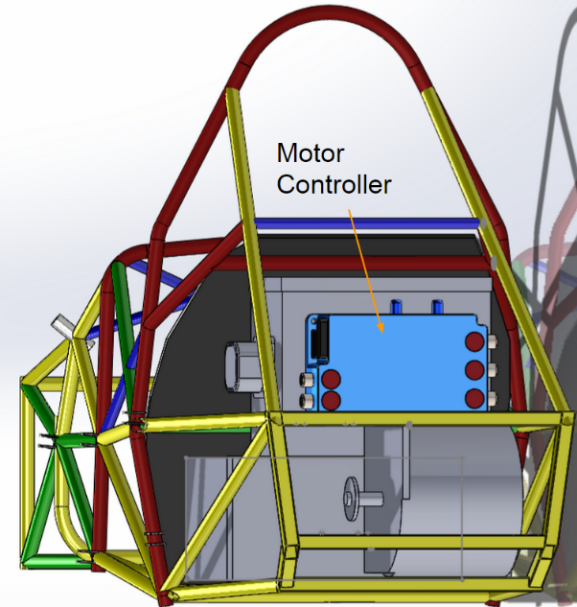 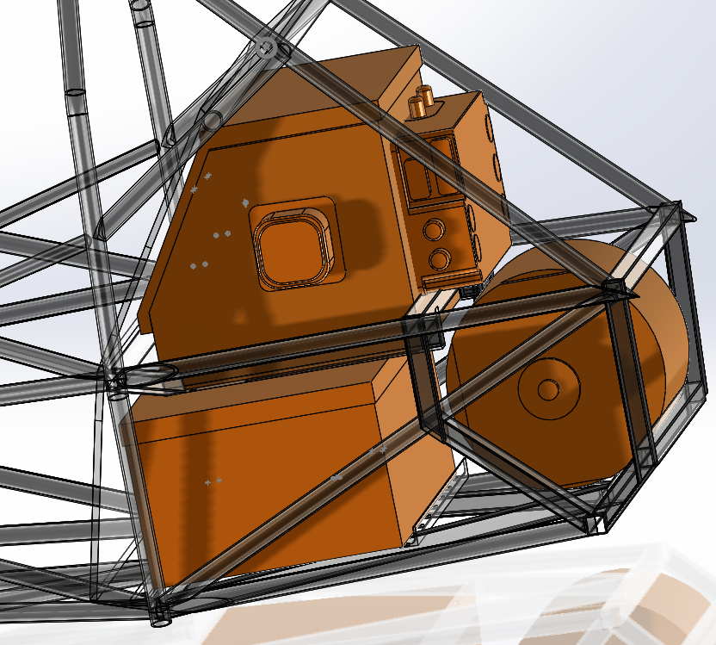

Figure 5‑1 Position of the motor controller (rear and isometric view)

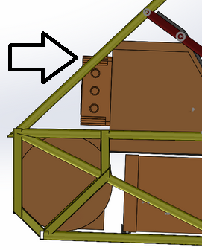

Figure 5‑2 Position of the motor controller (side view)

# Motors

## Motor 1

### Description, type, operating parameters

The Remy HVH 250 115 HT is the high torque (115mm core) version. The motor is rated for 87 kW peak power. This application runs at a reduced voltage (196V) and power rating (42kW). The motor is broken down into the following components:

1. Cartridge- The cartridge contains the bearings, rotor, stator and resolver. The cartridge is close-tolerance to ensure magnetic air gap.
2. Stator- The stator allows high current within the windings. It is 10-pole with series and parallel windings. It also contains temperature sensors to signal controller to limit power and excessive temperatures.
3. Rotor- The rotor provides magnetic performance by optimizing magnetic positioning, power density and rotational inertia.
4. Resolver- The resolver receives field coil excitation from, and returns sensor coil signals to the inverter to provide precision rotor position information for accurate synchronization of the signals supplied by the inverter.
5. Enclosure - The enclosure houses the cartridge, carries the shaft load, and supports the weight of the motor.The final motor enclosure is a 6 mm aluminum cylinder with two end plates.

Basic motor information is summarized in Table 6‑1. Figure 6‑1 shows plot of motor power and torque vs RPM.

|  |  |
| --- | --- |
| Motor Manufacturer and Type: | Remy HVH 250 |
| Motor principle | permanent magnet AC |
| Maximum continuous power: | 120 kW |
| Peak power: | 160kW |
| Input voltage: | 276 VAC |
| Nominal current: | 200 A |
| Peak current: | 300 A |
| Maximum torque: | 330 Nm |
| Nominal torque: | 248 Nm |
| Cooling method: | Oil-injected |

Table 6‑1 General motor data

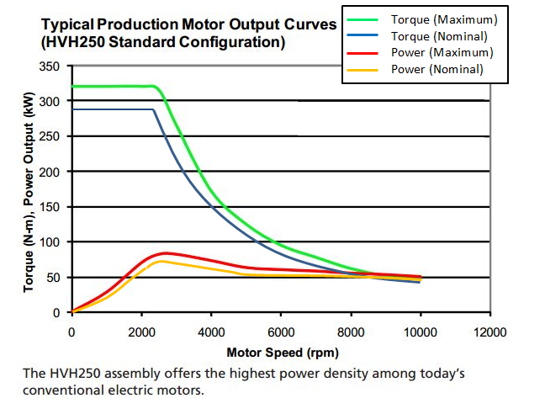

Figure 6‑1 Plot of power vs. RPM and Torque vs. RPM for Remy HVH250 motor

### Wiring, cables, current calculations, connectors

There are two connectors, one for low voltage and high voltage. The low voltage connector is a 10-pin Delphi Metri-pack 150. This is the resolver connector, and also transmits temperature data to the controller.

The high voltage is a 3 phase, 320 volt, 200 amp continuous, 300 amp peak connector. This application will require the wire to be rated at 220 amps for 196 volt use. As prescribed by the controller manufacturer, 2 AWG shielded cable is used, and the ampacity is 255A, and our tractive system is fused upstream in the accumulator containers to 70A. The line to line voltage is 196 volts, and the value is determined from the controller nominal voltage input:

$$V_{ac}=\frac{V_{DC}}{\sqrt{2}}=\frac{264}{\sqrt{2}}=196V$$

220 amps peak is determined from the power curve supplied by Remy for a 196 volt input.

The high voltage connector is a 2 AWG battery cable lug on each of the three motor phases. For this connection we choose the Molex 19221-0418 Battery Cable Lugs. The motor terminals have an OEM positive locking washer fixed on the terminals. The cables are attached to a housing with cable glands that require a wrench to remove, and the motor cables are shielded. The housing completely encloses the tractive system cables, and it is not possible to touch them with the housing in place. Orange conduit will be installed to protect the cables. The motor traction connection is shown in Figure 6‑2.

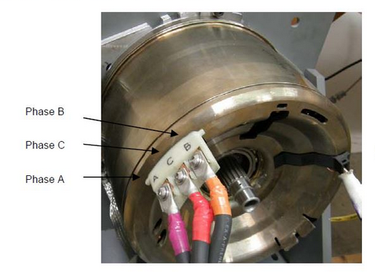

Figure 6‑2 Motor traction connection

### Position in car

The motor will be mounted at the rearmost structural section of the chassis, as shown in Figure 6‑3 and Figure 6‑4.

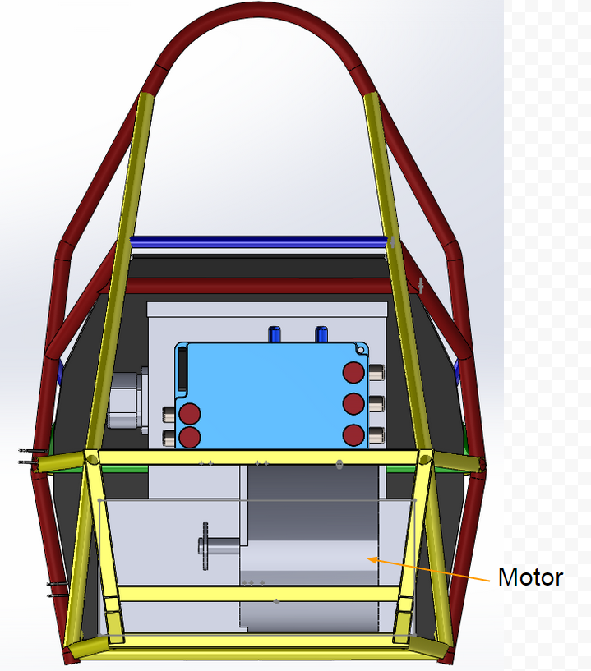

Figure 6‑3 Motor and enclosure placement (rear view)

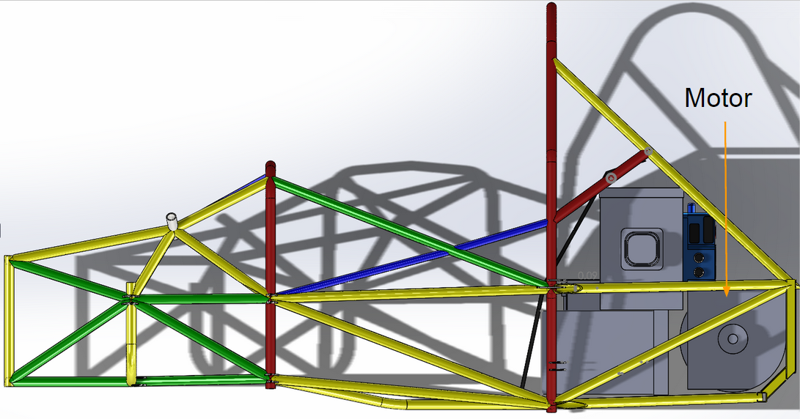

Figure 6‑4 Motor and enclosure placement (side view)

# Torque encoder

## Description/additional circuitry

The torque encoder used is originally from Toyota Prius and has two hall-effect position sensors, and produces two outputs. Basic info about the torque encoder is shown in Table 7‑1., the encoder diagram and output voltage mapping is shown in Figure 7‑1. The torque encoder signal is sent to the VCU to perform plausibility check. From VCU it is sent to motor controller. The signal is not amplified (the requested torque can be only lowered) before being sent to the motor controller.

|  |  |
| --- | --- |
| Torque encoder manufacturer and type: | [Toyota Prius Throttle Pedal 78120-47050](http://www.evwest.com/catalog/product_info.php?products_id=280&osCsid=glqa9mnomt0fgrhlplo6vgps42) |
| Torque encoder principle: | Hall-Effect |
| Supply voltage: | 5 VDC |
| Maximum supply current: | 20mA |
| Operating temperature: | -40 to 85 C |
| Used output: | 0-5V |

Table 7‑1 Torque encoder data

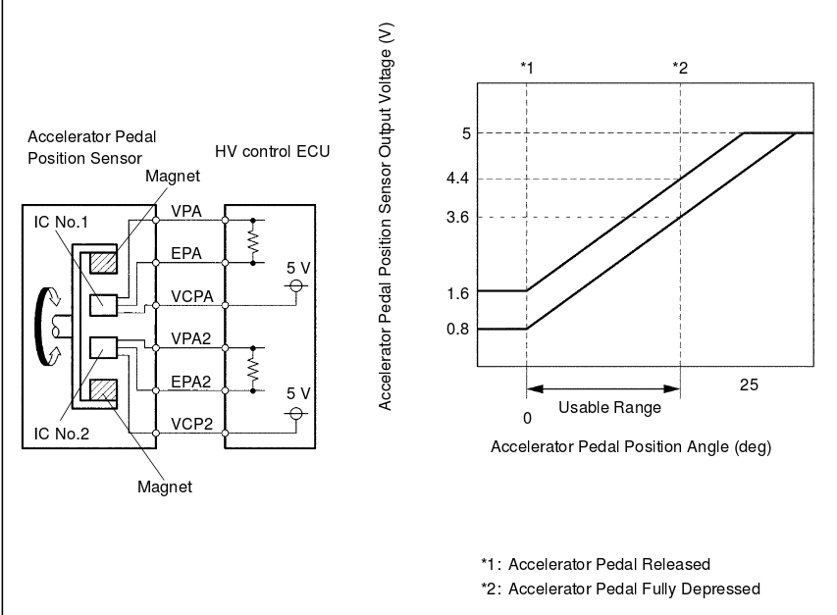

Figure 7‑1 Torque encoder functional description

## Torque Encoder Plausibility Check

The two torque encoders need to be within 10% pedal travel of each other. We know that the produced voltages are offset (see above), so first we have to map the voltages to a pedal position. If the implausibility occurs, motor controller is disabled (by opening ENABLE input to the controller) and the output voltage of the torque encoder is pulled low (0V). The encoder plausibilty checks work as following:

1. Feed both encoder outputs into analog inputs (0-5V) on VCU
2. VCU checks if the values are not below minimal threshold (1.6V and 0.8V respectively) – if so, that means the pedal is grounded, and motor controller is disabled
3. If both inputs are above high threshold (3.6V/4.4V) it means the encoder is open (analog inputs on VCU are internally pulled high) and the motor controller is disabled
4. VCU maps analog values to the throttle position (0.8V/1.6V = 0% throttle, 3.6V/4.4V = 100% throttle), the mapping is shown in Figure 7‑1
5. If both values are not within 10% of each other, the motor controller is disabled
6. 5V PWM output of VCU is conencted to motor controller analog input (0-5V). The lower of two encoder inputs is used as desired throttle for the controller. Throttle is mapped to PWM duty cycle (0% throttle = 0% PWM, 100% throttle =100% PWM duty cycle).
7. Internal RC filter on the motor controller smooths out PWM into analog value
8. Motor controller is set to use following thresholds (see Figure 7‑2), effectively performing another plausibility check:
   1. PEDAL_LO: minimal allowed voltage, lower value triggers controller fault and disables the controller
   2. ACCEL_MIN: voltage between PEDAL_LO and ACCEL_MIN is mapped to a constant regenerative torque (REGEN_LIMIT)
   3. COAST_LO: voltage betwen ACCEL_MIN and COAST_LO is linearly mapped to torque between REGEN_LIMIT and zero
   4. COAST_HI: voltage between COAST_LO and coast HI is mapped to zeto torque
   5. ACCEL_MAX: voltage between COAST_HI and ACCEL_MAX is linearly mapped from zero to max allowed torque
   6. PEDAL_HI: voltage higher than PEDAL_HI is considered a fault (open connection) and disables motor controller
9. If all checks passed, then the desired torque is applied by the motor controller

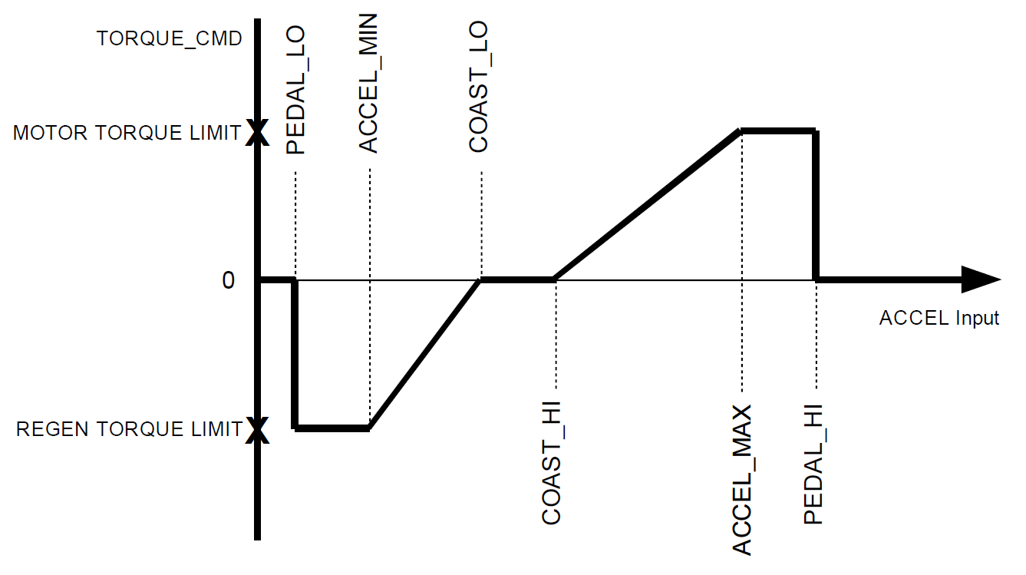

Figure 7‑2 Motor Controller troque input mapping

## Wiring

The wiring of the torque encoder is 18 AWG wire that connects to the plausibility system, and then to the motor controller. The internal voltage regulator in VCU provides 5V power for the throttle encoder. Simplified schematics is shown in Figure 7‑3.

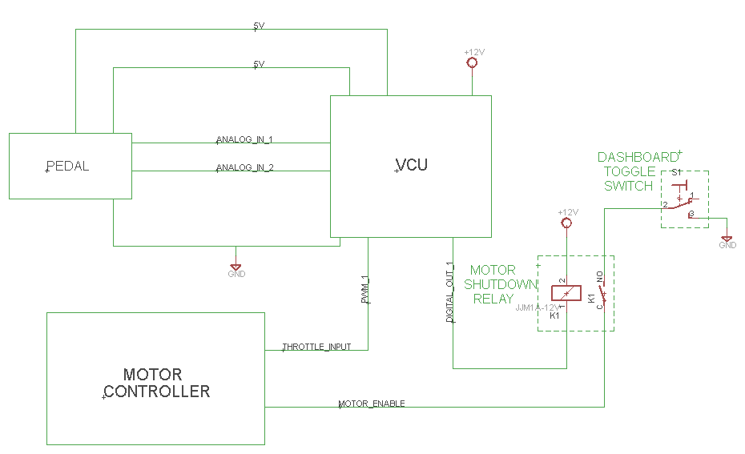

Figure 7‑3 Torque encoder wiring schematics (simplified)

## Position in car/mechanical fastening/mechanical connection

The torque encoder are hall-effect sensors located in an OEM accelerator assembly. The assembly is bolted to a 40 degree angled mount, which is bolted to the pedal box, as shown in Figure 7‑4.

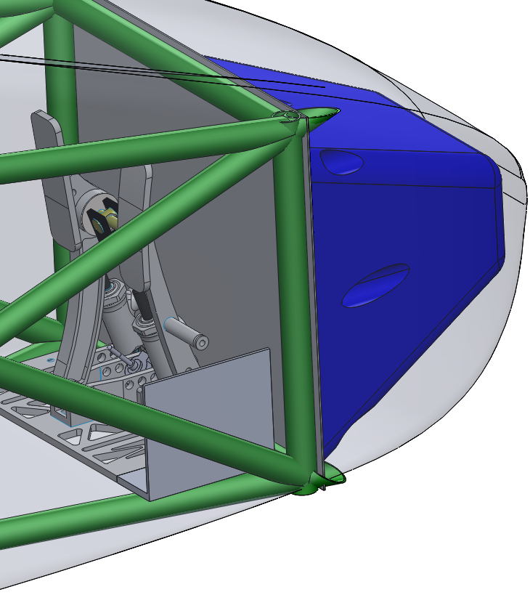

Figure 7‑4 Location of the pedal assembly

# Additional LV-parts interfering with the tractive system

## Vehicle Control Unit

### Description

Although VCU is not a part of tractive system, this section summarizes basic information about it. Our VCU is GEVCU (General Electric Vehicle Control Unit) from EVTV Motor Verks. VCU is interfacing several subsystems, and also serves as the main BMS board. VCU uses Arduino IDE for programming, and the custom code, located at: <https://github.com/podhrmic/Arduino_eVCU>

### Wiring, cables,

VCU is connected to the following subsystems:

* VCU – Motor controller:
  + Insulated CAN bus (RMS_CAN_H, RMS_CAN_L)
  + Digital output (FW_ENABLE_RELAY) to disable motor controller
* VCU – Throttle encoder:
  + Analog input (TEPD_ANIN) from torque encoder
  + PWM (TEPD_PWM_OUT) commanded torque
  + 5V power (TEPD_VDD) and ground (TEPD_GND)
* VCU – Battery Modules:
  + Insulated CAN bus (BMS_CAN_H, BMS_CAN_L)
  + 12V power (BMS-12V)
* VCU – AMS Latching circuit:
  + Digital output (AMS_LATCH)
* VCU – Shutdown circuit:
  + Digital output (SHUTDOWN_RELAY)
  + Digital input (SHUTDOWN_STATUS)
* VCU – Brake switch:
  + Digital input (BRAKE_STATUS)
* VCU – BSPD:
  + Digital input (BSPD_STATUS)
* VCU – IMD:
  + Digital input (IMD_STATUS)
* VCU – DC/DC Converter
  + Digital output (DC/DC_EN) as remote control for DC/DC converter (via relay)
* VCU – Dashboard
  + Digital output (AMS LED)

VCU has AMP Seal 35pin connector (identical to the connector on motor controller), and all LV wires will be18 AWG, rated for or above maximum tractive system voltage (196V). The pinout is shown in Figure 8‑1.

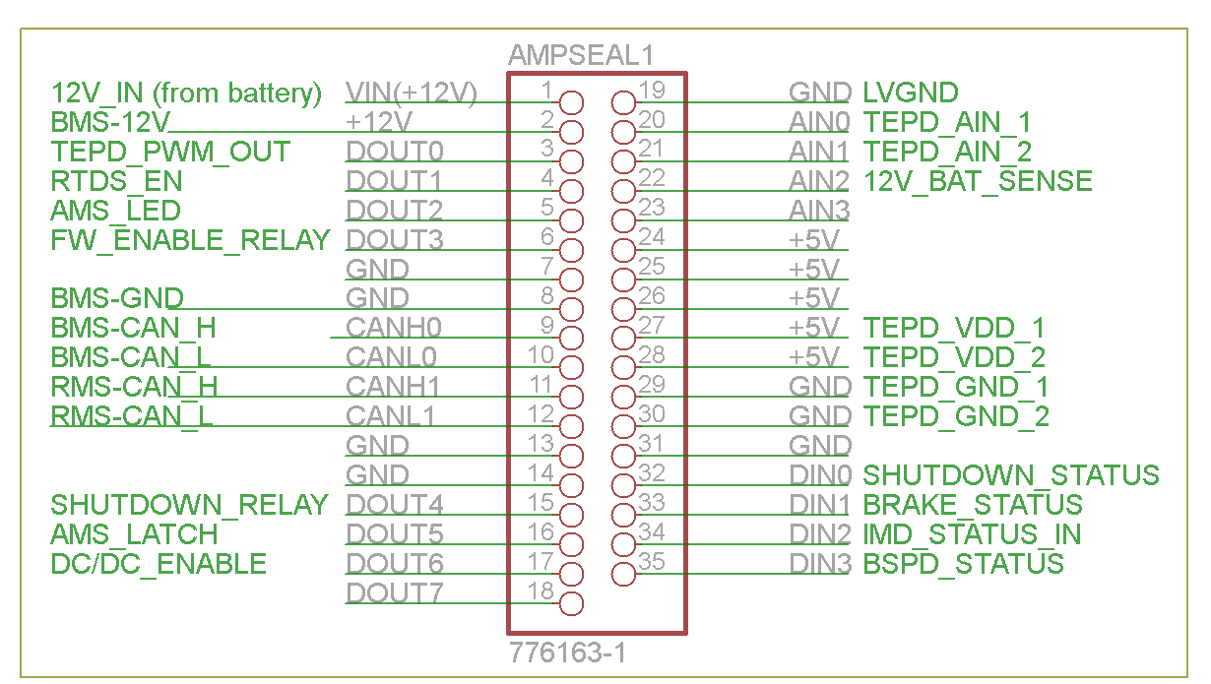

Figure 8‑1 VCU pinout

**Digital input** to VCU has a pull-up resistor (normally high) as shown in Figure 8‑2. That means the logic is inverted, i.e. if voltage is present on the input, VCU reads logic LOW.

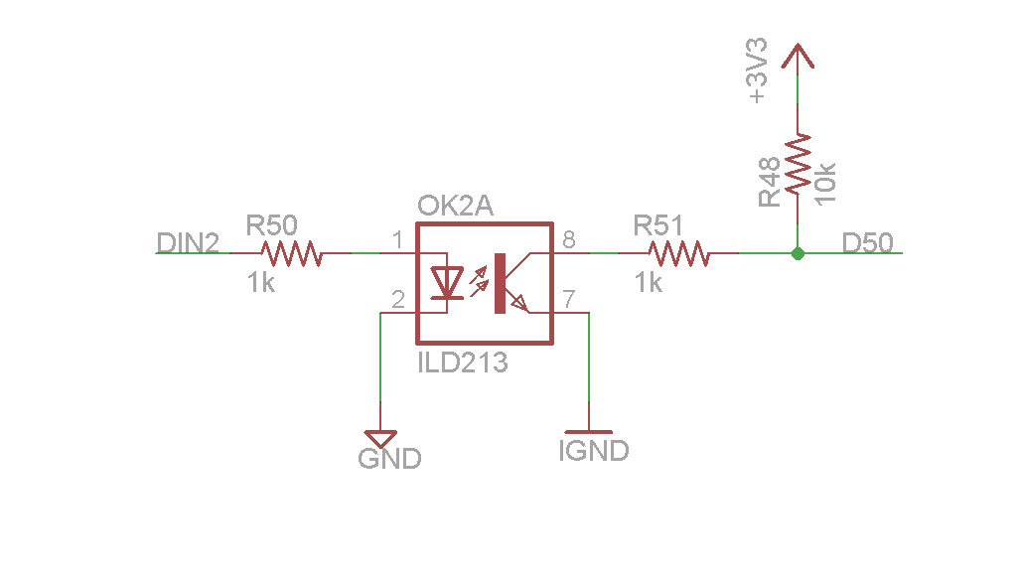

Figure 8‑2 VCU Digital input schematics, DIN2 is from the AMPSEAL connector, D50 goes directly into Arduino chip

**Digital Output** from VCU is a “sinking source” which means that when logic HIGH it connects the input to the LVGND and conducts, when logic LOW the input is floating and doesn’t conduct, as shown in Figure 8‑3.

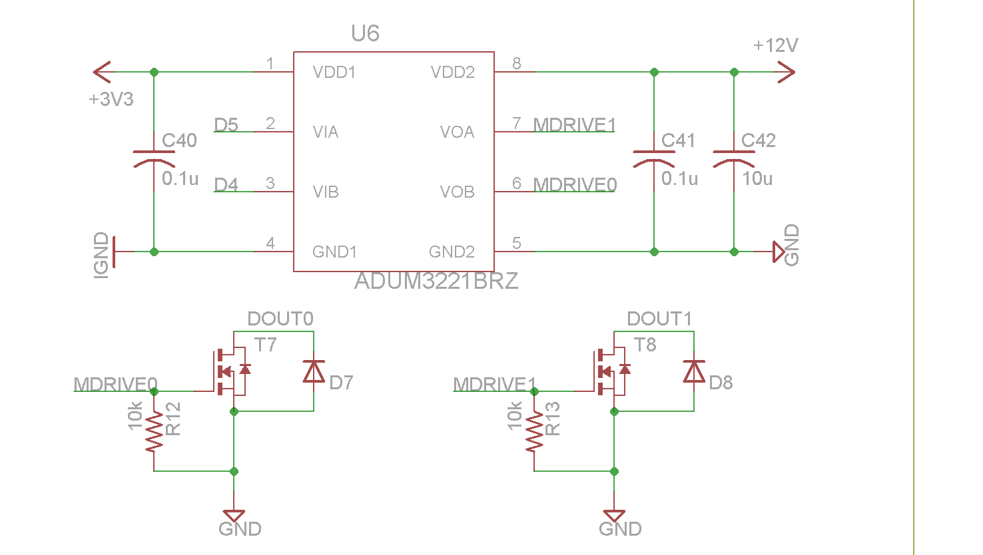

Figure 8‑3 VCU Digital output, DOUT0 and DOUT1 are on AMPSEAL connector, D4 and D5 are outputs from Arduino chip

Analog input is 12V tolerant, with a voltage divider of $V_{read}=\frac{10k}{10k+16k}=0.384 V_{in}$ and since the internal Arduino ADC is 3.3V max (and has 12-bit resolution), we can measure voltage in range of 0-8.5V, resolution is 8mV. For sensing 12V we need to add another voltage divider at the input. The analog input circuit is shown in

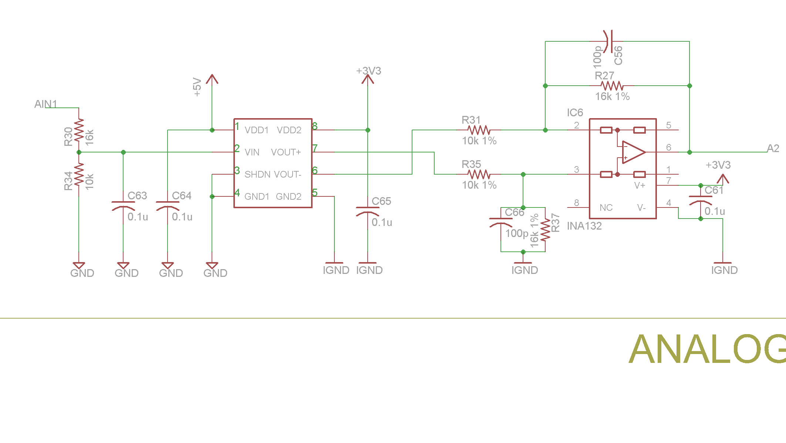

Figure 8‑4 VCU Analog input circuit, AIN1 is from AMPSEAL connector, A2 is analog input directly fed to Arduino chip

### Position in car

VCU is located from the left side of the top accumulator container, below the HVD switch, as shown in Figure 8‑5. It is fully protected by the chassis.

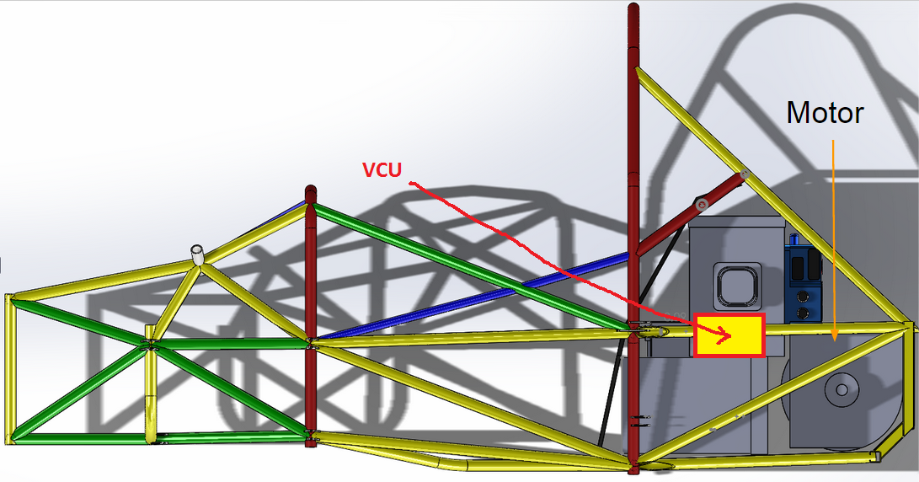

Figure 8‑5 VCU position (side view)

## DC/DC converter

### Description

We are using Mean Well SP-200-12 DC/DC converter to charge our LV motorcycle battery during the race. The converter accepts DC input from 120 to 370 VDC and provides 11.4-13.2-VDC output as shown in Figure 11‑9. Max output is 200W which at 12.6V means 15.8A max which is well within the current rating of 18AWG wire. We adjusted the controller to provide 13.9V Open-Loop Voltage because under load of 5A the voltage drops to convenient 12.4V.

### Wiring, cables,

The converter is connected to HV+ and HV- and is protected by a 5A 250V fuse. The output is fed directly to the LV battery. The connection diagram is shown in Figure 8‑6. The converter is controlled remotely from VCU, using a normally-open SSR relay on HV+ line. That way the DC/DC converter is switched off during charging. SSR is the same one as used for pre-charge and discharge (Opto 22 240D25). Our power budget is 7A (12VDC) during normal operation (including the pump cooling the motor controller), and 12A (12VDC) with the fan on.

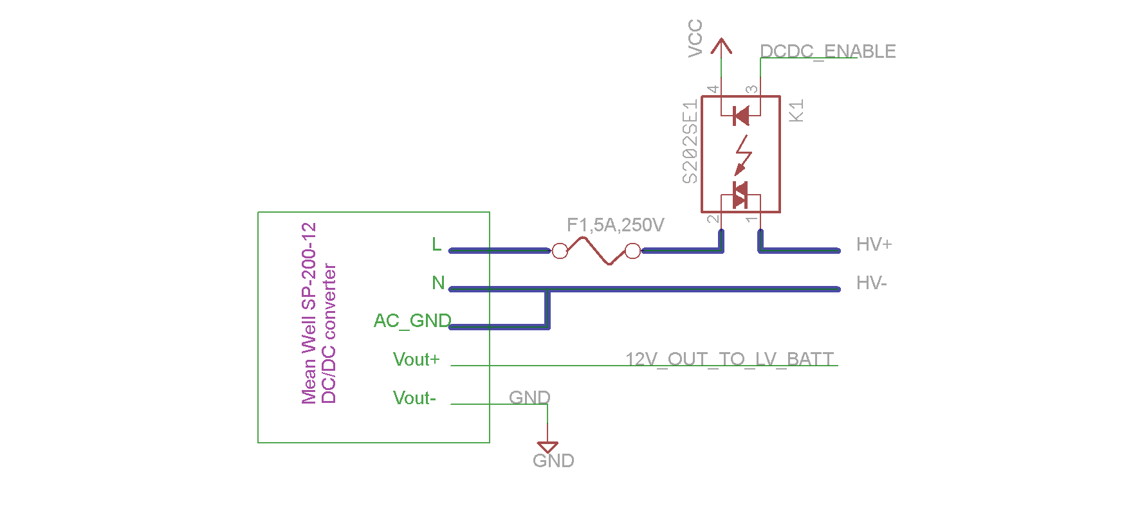

Figure 8‑6 DC/DC Converter connection diagram, HV lines are highlighted blue. DCDC_ENABLE goes directly to VCU digital output, 12V_OUT goes directly to LV battery.

### Position in car

DC/DC controller is located in the Accumulator Container 2 (lower), refer to Section 3 for details.

## Low Voltage Power Source

### Description

Although not connected to HV circuits, we think it is important to mention our LV power source. Our main LV power source is a standard motorcycle battery (12V, 30Ah). During normal operation the battery is charged by a DC/DC converter described in Section 8.2, which also provides current to all LV devices, so the battery is essentially a backup power source.

During charging, the DC/DC converter is disabled, and an external AC/DC converter located on the charging cart is used to power LV subsystems, see Section 3.1.10 for details.

### Wiring, Cables

Instead of a traditional fuse box, we are using a Power Distribution Module PDM60 from Rowe Electronics. PDM60 is essentially a programmable switching power supply regulating 12-16V to 12V output, designed for motorcycles and race cars. It has 6 outputs, each can be programmed to provide 1-20A. It also has LED indicator showing status of each output (OK/SHORTED), which makes it easier to locate a shorted circuit. In case a given output is shorted, PDM60 stops providing current in that circuit, acting like a fuse.

We are using PDM60 to provide stable 12V, and to make power distribution to LV subsystems easier. Wiring is shown in Figure 8‑7. Battery positive terminal goes directly to GLV Master Switch, then to PDM60, and from there to VCU, RMS, FAN, PUMP, the battery boxes, and shutdown circuit. VCU powers RLECS.

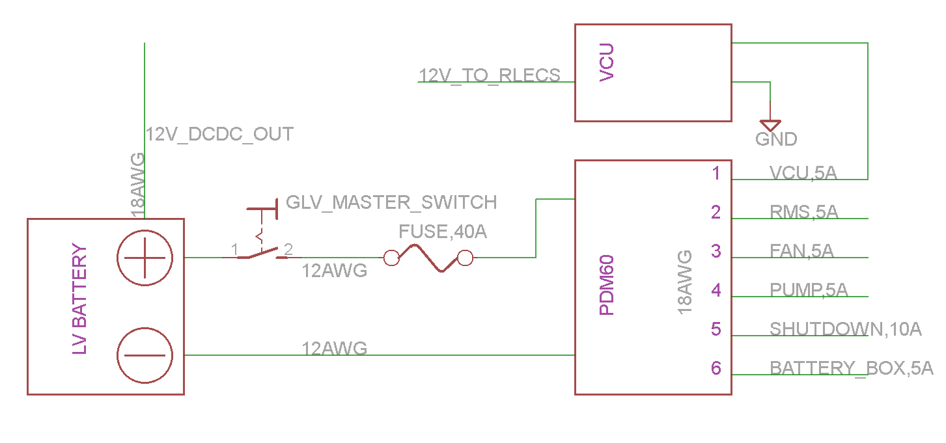

Figure 8‑7 LV power source wiring diagram, note 12AWG wire coming from battery to PDM60, and 18AWG wire used for rest of the LV subsystems.

### Position in car

The battery is places behind motor controller and above the motor as shown in Figure 8‑8, PDM60 is located next to the LV battery.

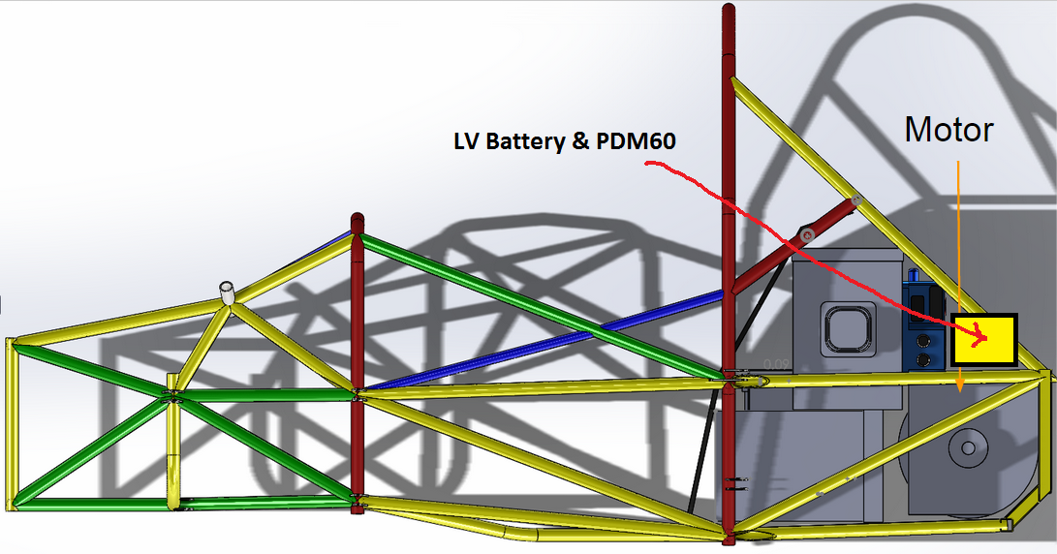

Figure 8‑8 Location of LV battery and PDM60 in the car (side view)

# Overall Grounding Concept

## Description of the Grounding Concept

The chassis of the car will be used as the common ground for the low voltage system. The chassis is made of steel, and will have additional connections to keep the resistance to common ground below the required 300 mOhms. This includes areas of the chassis within 100mm of the tractive system. Other components of the vehicle that may become conductive will have measures taken to ensure <5 Ohms resistance to common ground.

## Grounding Measurements

The 12V battery that supplies the GLVS is located in the LV component area below the driver’s seat. Measurements will be taken in several locations to ensure grounding requirements are met, and extra grounding straps added to keep resistance below 300 mOhms.  The fiberglass body is not within 100 mm of any HV component. Also fiberglass can’t possibly become conductive.

# Firewall(s)

## Firewall 1

### Description/materials

A 1/16” FR4 sheet with Aluminum on the motor side behind the seat is used as the firewall. The tractive side is 0.6 mm thick Aluminium. This material meets the required scratch and puncture resistance of the UL94-V0 standards.

### Position in car

The firewall placement is shown in Figure 10‑1

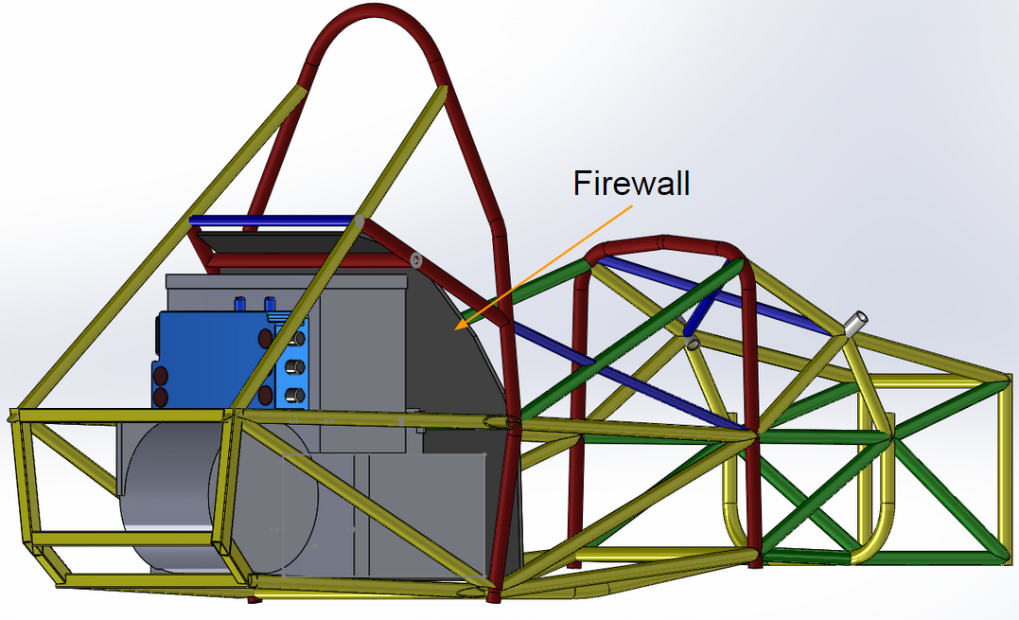

Figure 10‑1 Position of rear firewall

# Appendix

Xxx

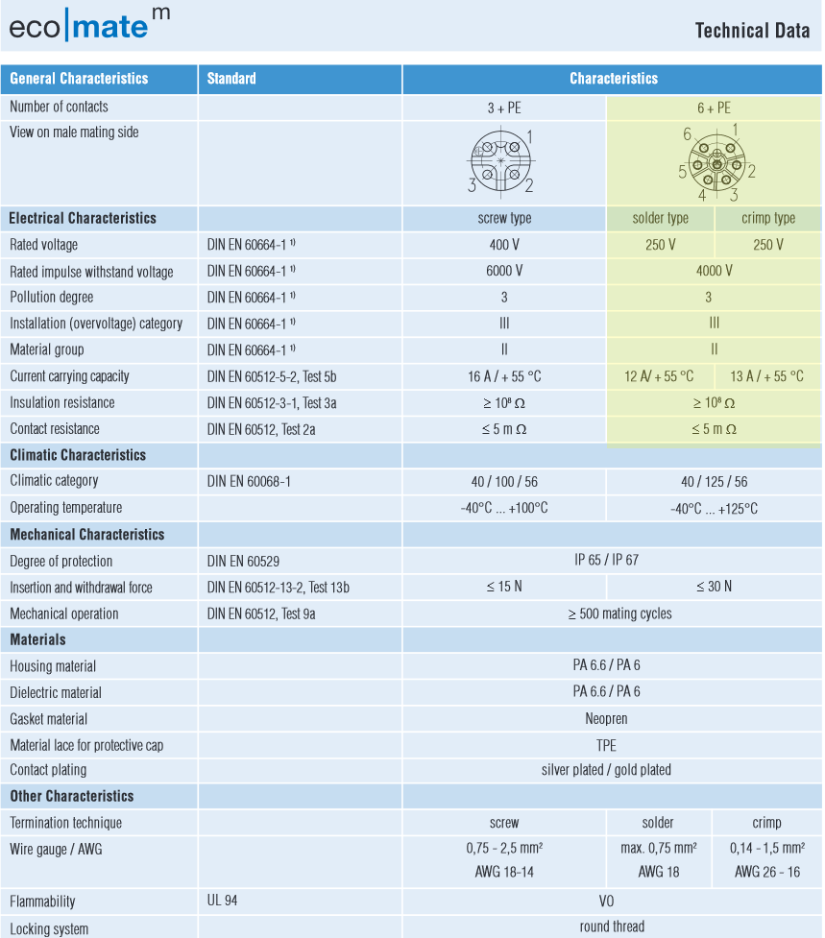

Figure 11‑1 (Section 2.6) TSMP Amphenol 6-pin DIN connector and receptacle, full datasheet available at <http://www.mouser.com/ds/2/18/28_ecomate_052009_e-86580.pdf>



Figure 11‑2 (Section 2.8) Shrouded banana jack for TSMPs

Complete data sheet located at: <http://www.mouser.com/ds/2/159/d6387_1_02-63150.pdf>

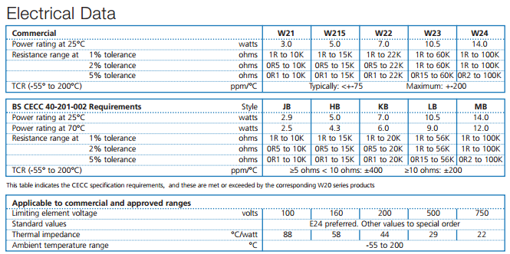

Figure 11‑3 (Section 2.8) Resistor for TSMPs

Complete data sheet located at: <http://www.mouser.com/ds/2/414/W20-461100.pdf>

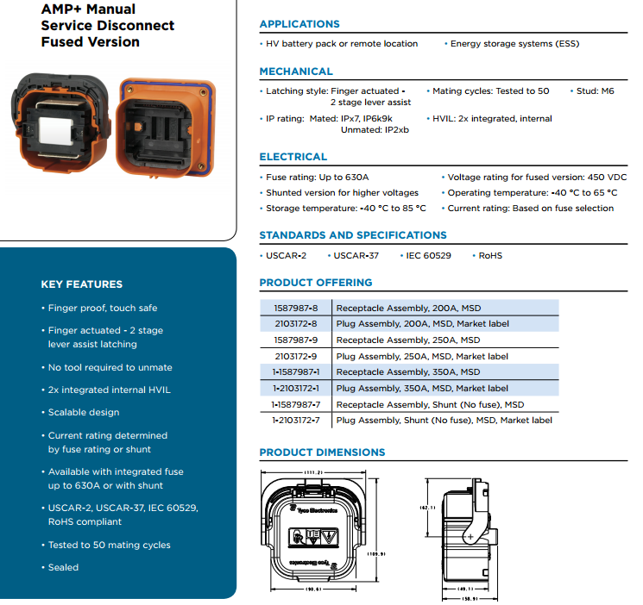

Figure 11‑4 (Section 2.11) HV disconnect, Complete data sheet located at: <http://www.te.com/content/dam/te/global/english/industries/hybrid-electric-mobility-solutions/amp-msd-tech-sheet.pdf>



Figure 11‑5 (Section 2.6) HV accumulator connector receptacle, Complete data sheet located at: <http://www.mouser.com/ds/2/276/1714669001_PCB_HEADERS-295262.pdf>

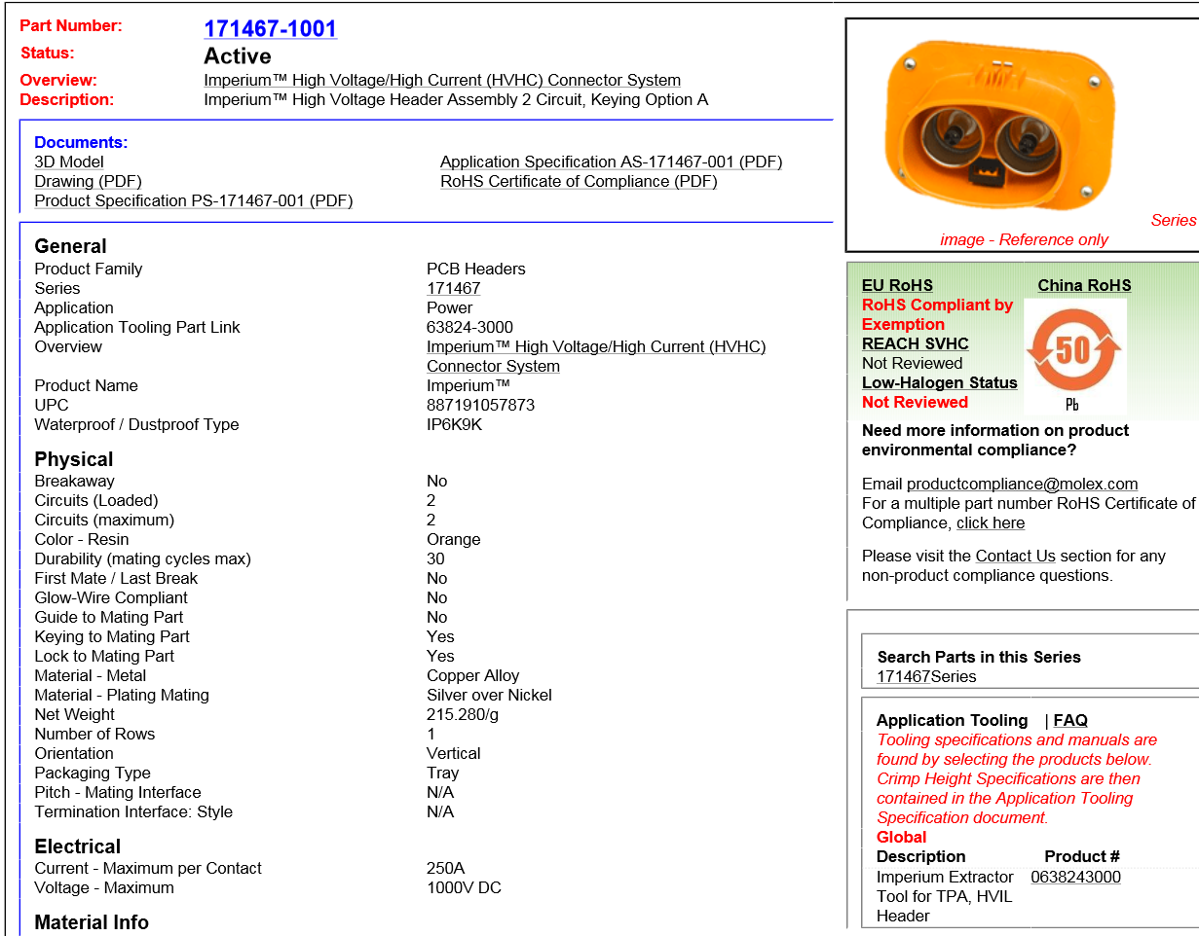

Figure 11‑6 (Section 2.6) HV accumulator connector header, full datasheet at <http://www.mouser.com/ds/2/276/1714671001_PCB_HEADERS-294724.pdf>

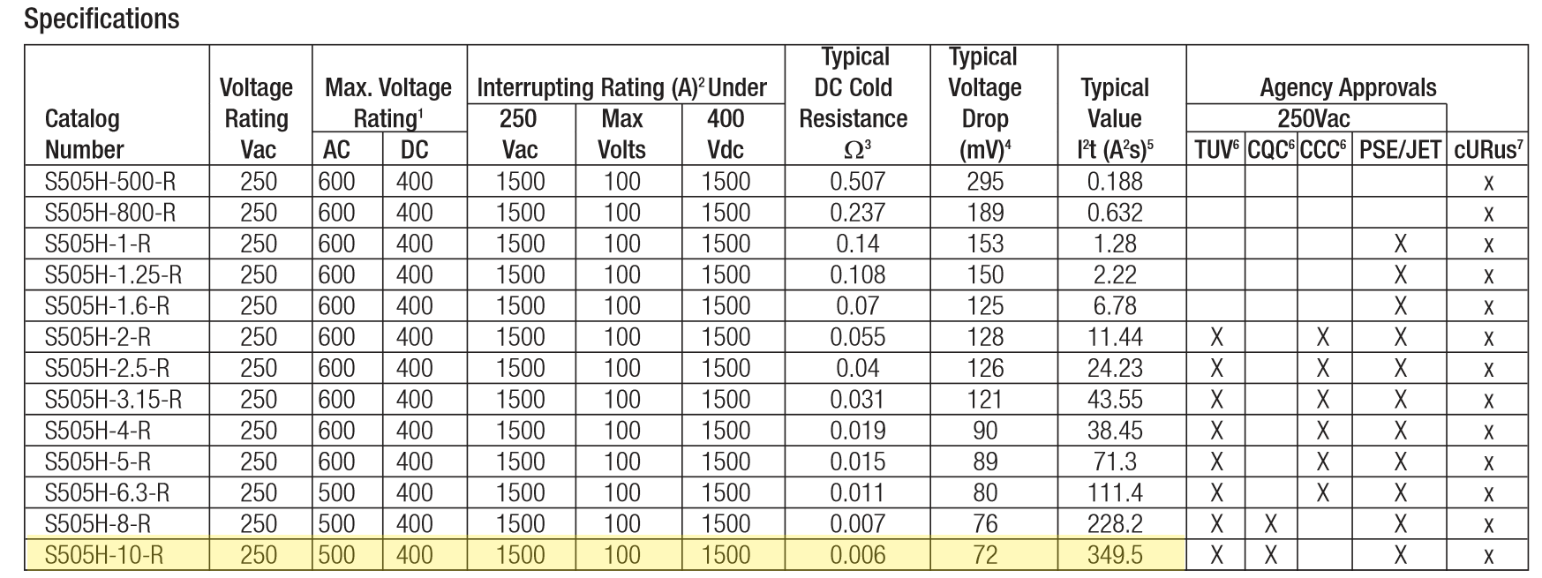

Figure 11‑7 (Section 2.1) S505H series fuse Complete datasheet at <http://www.mouser.com/ds/2/87/BUS_Elx_DS_4406_S505H_Series-335925.pdf>

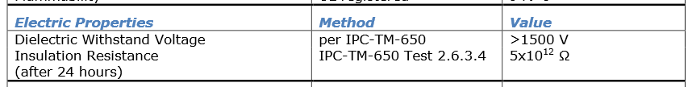

Figure 11‑8 (Section 2.7) Acrylic Conformal Coating 419C, full datasheet located at <http://www.mgchemicals.com/products/protective-coatings/conformal/acrylic-conformal-coating-419c/>

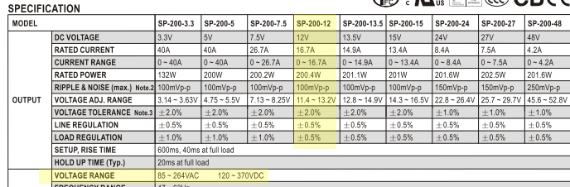

Figure 11‑9 (Section 8.2) DC/DC converter specs, complete datasheet located at <http://www.onlinecomponents.com/datasheet/sp200135.aspx?p=11953391>

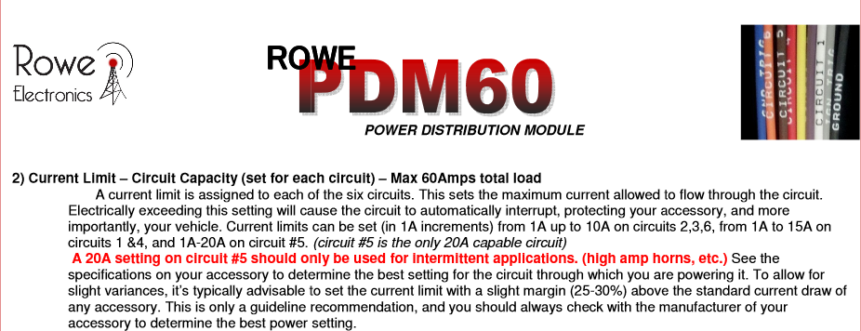

Figure 11‑10 (Section **Error! Reference source not found.**) PDM60 specs, complete datasheet located at <http://pdm60.com/wp-content/uploads/2014/08/PDM60-General-Installation-and-Operation-Manual-052213-1.pdf>

**Numbering according to chapter 1 to 10**

A datasheet for motor controller one for example has to have the numbering 11.10.5

Example appendix entry:

11.2.2 – Bender IR155-3203 IMD ratings

Referred from 2.1.1.

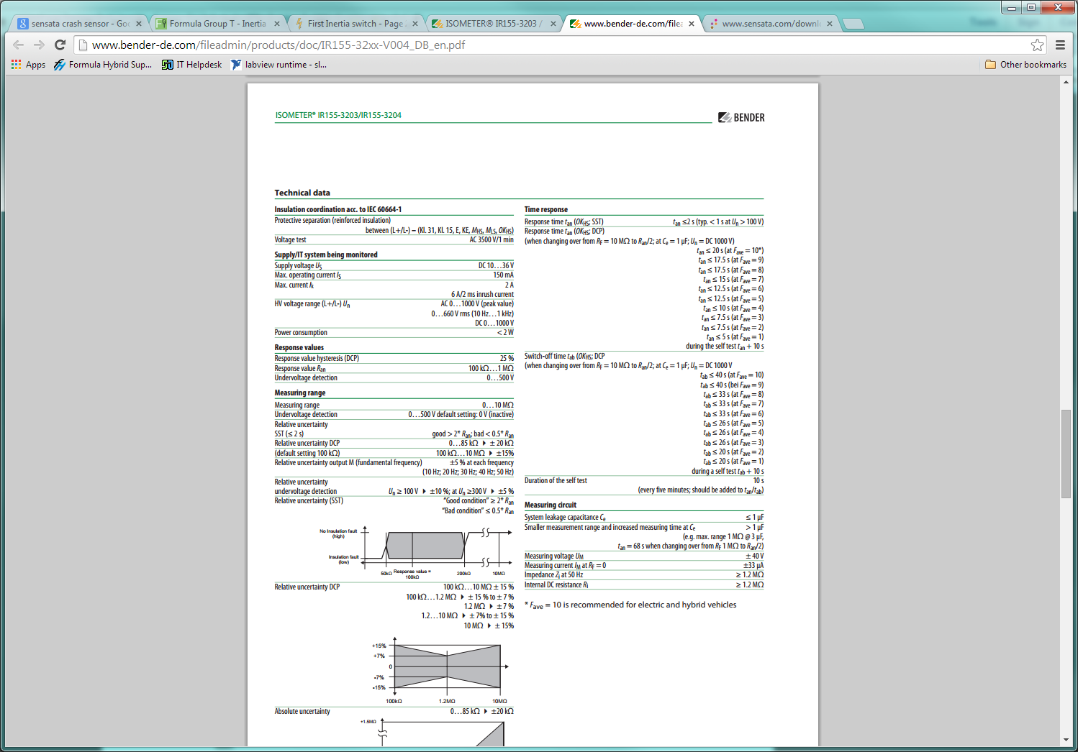

Complete data sheet located at: <http://www.bender-de.com/fileadmin/products/doc/IR155-32xx-V004_DB_en.pdf>

1. that is quite ambiguous term, but in our experience the brake pressure sensor won’t engage if you just tap the brake - the brake has to be actually pressed